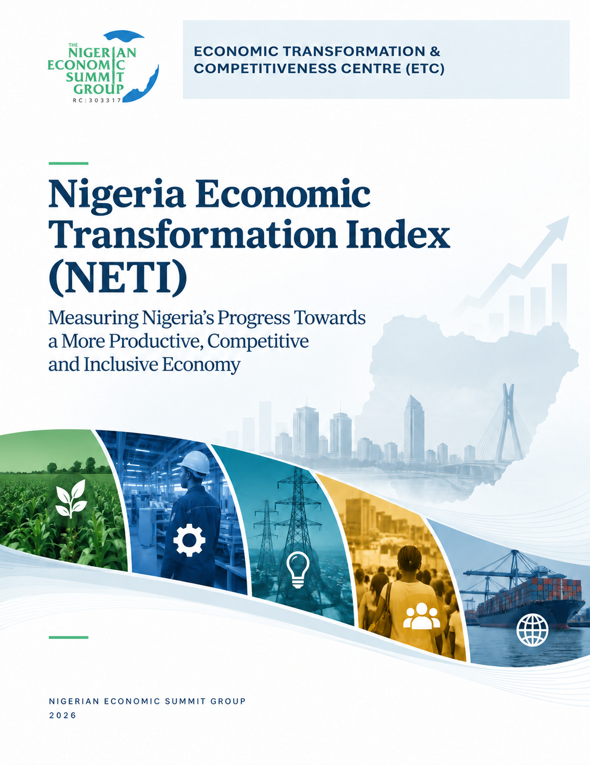
Nigeria Economic Transformation Index (NETI): Measuring Nigeria’s Progress Towards a More Productive, Competitive and Inclusive Economy
Prepared by the Economic Transformation & Competitiveness Centre (ETC), Nigerian Economic Summit Group (NESG)
Contributors: Dr Wilson Erumebor, Sodik Olofin, Dr Seyi Itiowe and Biodun Shittu
Nigerian Economic Summit Group
2026
Suggested citation: Nigerian Economic Summit Group (2026), Nigeria Economic Transformation Index (NETI): Measuring Nigeria’s Progress Towards a More Productive, Competitive and Inclusive Economy. Lagos/Abuja: NESG.

Table of Contents
EXECUTIVE SUMMARY 5
CHAPTER 1: THE TRANSFORMATION QUESTION 8
1.1 Nigeria’s Growth-Transformation Paradox 9
1.2 What Economic Transformation Means For Nigeria 11
1.2.1 From growth to transformation 11
1.2.2 A Nigerian definition of economic transformation 11
1.2.3 What would a transformed Nigerian economy look like? 12
CHAPTER 2: MEASURING NIGERIA’S ECONOMIC TRANSFORMATION 14
2.1 The SCALE Architecture: From Concept to Measurement 15
2.2 How the Nigeria Economic Transformation Index (NETI) Measures Economic Transformation 18
CHAPTER 3: WHAT NETI REVEALS ABOUT NIGERIA 23
3.1 Nigeria’s Transformation Trajectory, 2000 – 2025 24
3.2 What Has Driven the Overall Score? 26
3.3 Nigeria’s Transformation Gap 30
3.4 Diagnosing Nigeria's Transformation Challenge 31
CHAPTER 4: FROM STRUCTURAL CHANGE TO PRODUCTIVE TRANSFORMATION 33
4.1 What the NETI Diagnosis Means for Policy 34
4.2 Rebuild the Foundations of Productive Transformation 34
4.3 Turn Structural Reallocation into Productive Deepening 36
4.4 Make External Integration an Engine of Capability Building 36
4.5 Improve the Employment Outcomes of Structural Change 37
4.6 Sequence, Coordinate and Sustain the Transformation Agenda 38
CONCLUSION 40
REFERENCES 41
APPENDIX 1 42
Part I: Nigeria Economic Transformation Index (NETI) Methodology Note 42
PART II: NETI Methodology Note - Benchmark Construction and Comparator Evidence 46
APPENDIX 2: NETI HISTORICAL SCORES 51

List of Figures
Figure 1: Nigeria: Average Real GDP Growth by Period 9
Figure 2: Nigeria's transformation challenge at a glance 10
Figure 3: The SCALE Framework 15
Figure 4: The SCALE Relational Architecture 17
Figure 5: NETI Benchmark Component 20
Figure 6: NETI Weighting and Rationale 21
Figure 7: Four Ways to Read NETI 22
Figure 8: Nigeria Economic Transformation Index, 2000 - 2025 24
Figure 9: Trajectory of NETI Pillars, 2000 - 2025 27
Figure 10: Structural Reallocation in Nigeria, 2000 - 2025 27
Figure 11: Competitiveness & Business Environment in Nigeria, 2000 - 2025 28
Figure 12: Absorptive & Productive Capacity in Nigeria, 2000 - 2025 28
Figure 13: Labour, Jobs & Inclusion in Nigeria, 2000 - 2025 29
Figure 14: External Competitiveness & Global Integration in Nigeria, 2000 - 2025 29
Figure 15: Nigeria’s Transformation Gap, 2000 – 2025 30

List of Tables
Table 1: Nigeria Economic Transformation Index: Pillars, Dimensions, Focus and Indicators 19
Table 2: Interpreting NETI Scores 22
Table 3: Nigeria Economic Transformation Index and Pillars 26
Table A1: NETI and pillar scores, 2000-2025 51
Table A2: Indicator Scores, Selected Years (0 - 100 scale) 52

EXECUTIVE SUMMARY
The Nigeria Economic Transformation Index (NETI) assesses how Nigeria’s economy has changed across five areas: Structural Reallocation; Competitiveness & Business Environment; Absorptive & Productive Capacity; Labour, Jobs & Inclusion; and External Competitiveness & Global Integration. It tracks changes in indicators such as productivity, firm capability, competitiveness, exports and employment, and assesses whether these changes are moving Nigeria toward stronger economic transformation over time.

Nigeria’s overall transformation performance improved in the 2000s; however, the gains were not sustained. The weighted NETI rose from 27.0 in 2000 to a peak of 34.0 in 2008, before falling to 25.4 in 2025, slightly below its level in 2000 and still within the Weak Transformation Performance range. The threshold for Strong Transformation Performance is 60, leaving Nigeria with a transformation gap of 34.6 points in 2025, compared with 26.0 points at the 2008 peak. This gap measures the distance from stronger transformation benchmarks; it should not be interpreted as a percentage measure of how “transformed” the economy is.

What changed across the five pillars?
Performance across the five pillars moved in different directions over the period.
- Structural Reallocation recorded the strongest improvement, rising from 11.2 in 2000 to 35.5 in 2025. Labour moved away from agriculture, manufacturing employment increased and tradable services expanded.
- Competitiveness & Business Environment fell sharply from 45.1 to 23.8. Improvements in electricity access and digital connectivity were outweighed by persistent weaknesses in productive finance, periods of high inflation and exchange rate volatility, weaker fiscal performance and poor regulatory quality.
- Absorptive & Productive Capacity declined from 26.9 to 12.5. Industrial productivity, manufacturing capacity utilisation, electricity consumption and technological absorption remained weak, limiting the ability of firms to expand and upgrade.
- Labour, Jobs & Inclusion improved modestly from 29.5 to 31.7. Financial inclusion expanded and some labour market indicators improved, although informality remained very high and wage employment was limited.
- External Competitiveness & Global Integration increased from 16.9 to 26.5. Nigeria strengthened its external position in some respects - reserve adequacy and the relationship between external debt and reserves - while export sophistication, manufacturing export orientation and economic complexity remained weak.

Overall, three pillars improved, while Nigeria’s foundational conditions and productive capabilities weakened substantially. The decline in Competitiveness & Business Environment and Absorptive & Productive Capacity was large enough to outweigh gains elsewhere.

What does this tell us about Nigeria’s transformation?
The first finding is that Nigeria has changed the structure of economic activity faster than it has strengthened the productive capabilities beneath that structure. Structural Reallocation recorded the largest improvement, while Absorptive & Productive Capacity deteriorated significantly. Labour and economic activity therefore shifted across sectors without a comparable strengthening of productivity, technology absorption and industrial capability.

The second finding is that both foundational conditions and productive capabilities weakened over time. Together, Competitiveness & Business Environment and Absorptive & Productive Capacity account for 45 percent of the overall index. Their deterioration offset gains elsewhere and left Nigeria with a weaker basis for sustained transformation.

The third finding is that progress has been difficult to sustain. Nigeria moved substantially closer to stronger transformation performance during the 2000s, but much of that progress was subsequently reversed. This reinforces the point that gains in individual areas need to be sustained long enough for investment, firm capability and productivity to accumulate.
The fourth finding is that the External Competitiveness & Global Integration pillar improved, driven mainly by stronger external buffers and some changes in export composition. However, export sophistication and domestic productive capability remain weak, indicating that greater external resilience has not yet been matched by comparable progress in productive and export upgrading.

These findings are particularly relevant to Nigeria’s current macroeconomic reform agenda. Recent reforms have strengthened macroeconomic stability and external resilience, although conditions remain difficult for many households and firms. For transformation, the important question is whether greater stability is accompanied over time by stronger productive investment, access to finance, capacity utilisation, technology adoption, export upgrading and better employment outcomes. NETI is designed to track these broader changes in the economy.

Policy priorities
The findings point to five broad priorities:
- Rebuild the foundations for productive investment. Sustained macroeconomic stability, reliable infrastructure, productive finance and greater regulatory predictability are necessary for firms to invest, expand and upgrade.
- Strengthen firm and sector capabilities. Technology adoption, management capability, skills, supplier development and better access to finance and infrastructure should be concentrated around sectors and clusters with the potential to raise productivity and scale.
- Improve the quality of structural change. Agricultural productivity needs to rise while manufacturing, agro-processing and tradable services deepen sufficiently to absorb labour into more productive activities.
- Use external integration more deliberately for upgrading. Trade, regional integration and foreign investment should support export sophistication, technology transfer, domestic supplier development and access to larger markets, while stronger external buffers are preserved.
- Improve employment outcomes. Policy should support the growth of firms capable of creating productive wage employment, improve the alignment between skills and labour demand, and create more viable pathways from informal to formal work.

The main message from NETI is that Nigeria has made more progress in changing the structure of economic activity than in strengthening the conditions and productive capabilities needed to support that change. The experiences of countries such as Indonesia and China show that transformation requires different parts of the economy working together to achieve a common goal. Narrowing Nigeria’s transformation gap will require a coherent transformation agenda that focuses on sustained improvements in the conditions for production, stronger firm capabilities and greater progress in productivity, exports and employment.

CHAPTER 1: THE TRANSFORMATION QUESTION

Nigeria’s Growth-Transformation Paradox
Nigeria’s economic history over the past three decades presents an important paradox. The economy has grown, sometimes rapidly, and that expansion has not produced a commensurate transformation in productivity, employment and poverty reduction. Average annual real Gross Domestic Product (GDP) growth rose from 2.3 percent in the 1990s to 7.7 percent in the 2000s, then slowed to 3.7 percent in the 2010s and 3.3 percent from 2020 to 2025. The economy is therefore larger than it was at the beginning of the century; however, the quality and structural composition of growth have remained much weaker than the headline expansion in output suggests.

Figure 1: Nigeria: Average Real GDP Growth by Period

Source: Central Bank of Nigeria; National Bureau of Statistics; NESG ETC calculations

On headline growth, Figure 1 shows that average real GDP growth between 2020-2025 was less than half the rate recorded in the 2000s. This matters because even the much stronger growth of the 2000s did not generate sufficiently broad-based gains in productivity, employment quality and poverty reduction. At today’s slower pace, the economy has even less room to absorb a rapidly growing labour force, raise incomes and generate the scale of structural change required for inclusion. Current growth, therefore, is insufficient in its magnitude.

The quality of growth over the past three decades remains an issue of concern. The World Bank (2026) currently estimates that about 63 percent of Nigerians lived below the national poverty line in 2025, up from an estimated 40 percent in 2019. While employment expanded in the last two decades, there has been limited transition of workers towards secure and productive work. According to the National Bureau of Statistics (2024a), 93 percent of employment was informal in Q2 2024, and wage employment accounted for only 14.4 percent of employment. Growth, in other words, has coexisted with persistent poverty and an employment structure dominated by informality.

Figure 2: Nigeria's transformation challenge at a glance
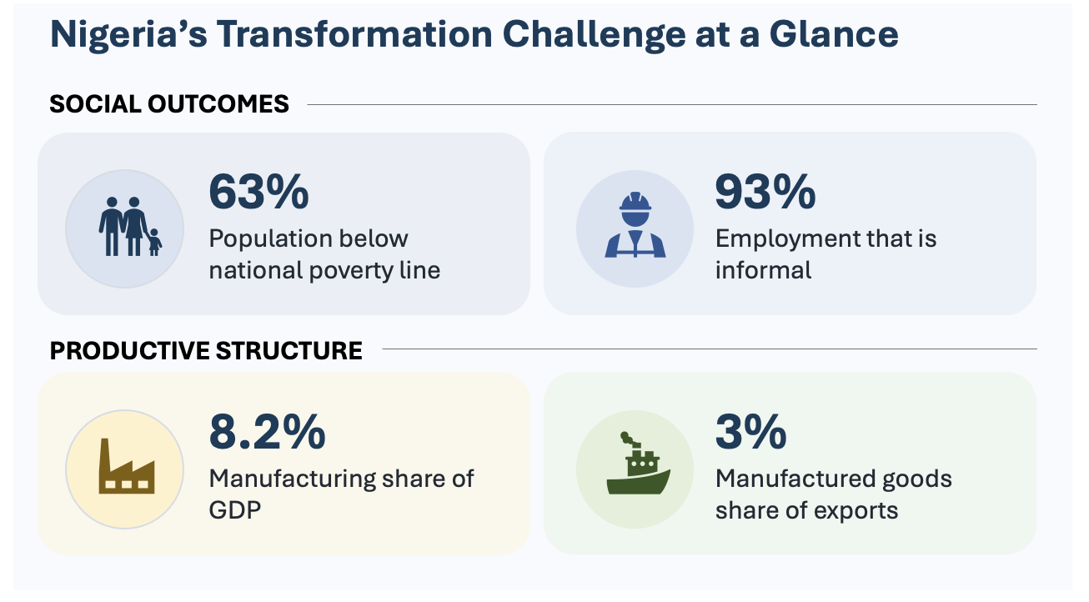
Source: National Bureau of Statistics; World Bank; NESG ETC calculations

The quality of growth is also reflected in the structure of production and exports. Manufacturing remains shallow, contributing 8.2 percent of GDP in 2025, while agriculture still accounts for about a quarter of output and employs a larger share of the workforce. Services now account for close to 60 percent of GDP and over 50 percent of employment (NBS, 2026a & 2024b). While modern services such as telecommunications, finance and professional services have expanded rapidly, a large share of employment remains concentrated in lower-productivity informal and non-tradable services (Erumebor, 2025). Nigeria has therefore experienced a change in the structure of its economy but not yet the depth of industrialisation, productivity growth and productive job creation associated with sustained economic transformation.

Nigeria’s external structure, especially in relation to exports, shows the same concern. Non-oil exports still accounted for about 14 percent of goods exports in 2025, while manufactured goods represented only 3 percent of total exports. This concentration of oil-related exports leaves the economy exposed to commodity cycles and, by extension, could limit the scope for industrial learning, technological upgrading and participation in higher-value regional and global production networks.

Recent reforms have begun to restore a degree of macroeconomic stability, with external reserves reaching US$55 billion in September 2026, an 18-year high, according to data from the Central Bank of Nigeria (CBN). Exchange rate has maintained relative stability and portfolio investment reached US$19.7 billion in 2025 (NBS, 2026b), one of the highest inflows in the past decade. Despite these gains, household conditions remain difficult and poverty remains high. The important question for economic transformation is whether greater macroeconomic stability is accompanied over time by stronger productive investment, more competitive firms, higher productivity, export upgrading and better jobs.

This is the central question that motivates the Nigeria Economic Transformation Index (NETI). NETI shifts the focus from whether the Nigerian economy is growing or stable to whether it is becoming more productive, competitive, diversified and inclusive.

What Economic Transformation Means For Nigeria

From growth to transformation
Section 1.1 showed that Nigeria has recorded periods of strong economic growth; however, the gains have been uneven, recent growth has slowed and the productive structure has changed only gradually. Growth has also remained vulnerable to external shocks, while improvements in productivity, employment quality and household welfare have lagged. The result is an economy that has expanded without achieving the scale of transformation required to raise living standards on a sustained basis.

Economic growth captures changes in the volume of goods and services produced over time. Economic transformation is concerned with changes in the structure and capabilities of the economy, i.e. where labour and capital are employed, how productive firms and workers are, what the economy produces, how firms learn and upgrade, and how effectively the country and its firms compete in domestic and international markets.

From a theoretical standpoint, Lewis (1954) emphasised the movement of labour from low-productivity traditional activities into more productive modern sectors. Kuznets (1966) and Chenery and Syrquin (1975) showed that development is accompanied by systematic shifts in production, employment and productivity. More recent work has placed greater emphasis on productive capabilities, technological learning, firm upgrading, and the diversification and sophistication of production and exports (McMillan et al., 2017).

For Nigeria, the implication is that sustained prosperity will depend on a growth process that steadily raises productivity, strengthens firms, deepens domestic value creation, expands productive employment and shifts resources towards activities with greater scope for learning, scale and technological upgrading.

A Nigerian definition of economic transformation
Nigeria’s transformation challenge is influenced by several features of its economy. It has a large domestic market, a rapidly growing labour force with a large informal economy, weak industrialisation, oil dependence and uneven productive capabilities across sectors. Institutional weaknesses further constrain policy coordination, implementation and the business environment. A Nigerian definition of economic transformation must therefore speak directly to these realities and to the kind of economy Nigeria needs to build over the coming decades.

For the purpose of NETI, economic transformation is defined as:

The cumulative process through which Nigeria builds increasingly sophisticated productive capabilities, reallocates labour and capital towards higher-productivity activities, deepens domestic value creation, strengthens competitiveness, diversifies production and exports, expands productive and inclusive employment, and builds resilience, thereby sustaining improvements in incomes and living standards.

Three ideas are central to this definition.

The first is foundational conditions and productive capabilities. Transformation requires an economic environment that supports productive investment and firms with the capabilities to learn, adopt technology, raise productivity and compete. This combines the enabling conditions created by infrastructure, finance, macroeconomic stability and institutions with the productive capabilities embedded in firms and sectors.

The second is transformation processes. Labour and capital progressively move towards higher-productivity activities, while firms and sectors deepen their participation in more sophisticated domestic, regional and global markets. In Nigeria, this means raising productivity within agriculture, expanding manufacturing and modern tradable services, diversifying exports and strengthening international competitiveness.

The third is the transformation outcome. Transformation should ultimately be reflected in better labour market and household outcomes through more productive jobs, higher incomes and broader access to economic opportunity.

This definition provides the conceptual foundation for NETI and a basis for assessing how far Nigeria has moved towards a more productive, competitive, diversified, inclusive and resilient economy.

What would a transformed Nigerian economy look like?
A transformed Nigerian economy would have a sophisticated productive economic structure. It should reflect changes in the composition, capabilities and organisation of production that enable prosperity to be sustained across successive generations. Manufacturing would account for a much larger share of output and employment, approaching benchmark levels of around 30 percent of GDP and over 20 percent of total employment. Agriculture would become substantially more productive and account for a smaller share of employment as manufacturing, agro-processing and modern services expand. This means that the sector would support the country’s food security agenda and become connected to agro-processing and domestic value chains. Modern services (finance, ICT, professional services) would expand alongside these sectors and contribute more to productivity, exports and employment.

Firms would operate with more reliable electricity and infrastructure, stronger access to productive finance and greater technological capability. Investment in machinery, skills, research, digital technologies and organisational upgrading would increase significantly, enabling more Nigerian firms to scale and compete. Access to productive finance would improve substantially, with a larger share of credit going to manufacturing and other productive activities. As a result, many Nigerian companies would produce goods and services for the larger African market, leveraging the opportunities that come with the African Continental Free Trade Area (AfCFTA) Agreement.

There would also be changes in the labour market and improvements in inclusion. Wage and salaried employment would account for a much larger share of total employment, moving towards benchmark levels of around 60 percent, while informality and working poverty decline. The number and share of Nigerians living in poverty would decline substantially as productivity, employment quality and real incomes improve. Nigerians would have access to affordable healthcare and education and the quality of both services would significantly improve.

Nigeria’s external structure would become more diversified. Certainly, crude oil would remain relevant; however, the export structure would become more diversified, with manufactured goods accounting for a much larger share of total export earnings and moving towards benchmark levels of around 40 percent. Nigerian firms would participate in regional and global value chains, while exports would increasingly reflect accumulated domestic capabilities.

A broader productive base would also strengthen resilience, especially as economic growth would become less exposed to commodity cycles and foreign exchange shocks. External buffers would also strengthen, with reserves providing more adequate import cover and external obligations becoming more manageable relative to available reserves.

These features provide a practical picture of the economy Nigeria should aim to build in the next decade. Importantly, this vision should not be interpreted as a fixed destination or an idealised end-state, especially because economic transformation is dynamic. As technologies evolve, markets deepen and new industries emerge, the frontier of transformation also shifts. The objective is, therefore, to place Nigeria on a sustained trajectory of continuous structural upgrading. For this reason, NETI benchmarks are grounded in the experience of select economies such as China, Indonesia, Malaysia, Thailand and South Africa, while remaining sufficiently forward-looking to accommodate future advances in productivity, competitiveness and economic complexity.

CHAPTER 2: MEASURING NIGERIA’S ECONOMIC TRANSFORMATION

The SCALE Architecture: From Concept to Measurement
As stated in Chapter 1, economic transformation is a cumulative process of building productive capabilities, reallocating resources towards higher-productivity activities, strengthening competitiveness and improving economic opportunities. To translate this definition into measurable dimensions, the NESG Economic Transformation & Competitiveness Centre developed the SCALE architecture, which consists of five pillars of transformation.

S - Structural Reallocation
C - Competitiveness & Business Environment
A - Absorptive & Productive Capacity
L - Labour, Jobs & Inclusion
E - External Competitiveness & Global Integration

Figure 3: The SCALE Framework
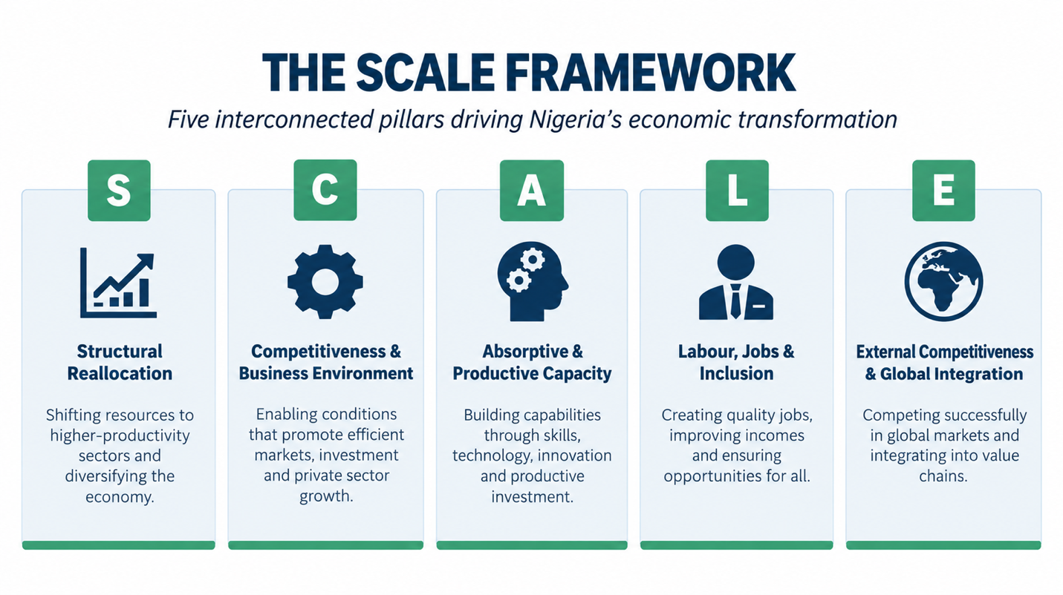
Each pillar explains a distinct aspect of the transformation process.

Structural Reallocation (S) is about changes in what an economy produces and how people work. It asks whether labour and capital are moving into sectors that are more productive, better connected to other parts of the economy, and more capable of growing at scale.

Competitiveness & Business Environment (C) covers the conditions firms face when they invest, produce and expand. This includes macroeconomic stability, fiscal conditions, infrastructure, access to finance, and the quality of the business environment. These factors matter because they affect the costs, risks, and incentives that shape productive activities.

Absorptive & Productive Capacity (A) refers to the economy’s ability to raise productivity through investment, technology, learning, and the accumulation of capabilities. It is about whether firms and sectors can take in new knowledge, upgrade what they do and move into more complex activities.

Labour, Jobs & Inclusion (L) looks at how transformation affects people’s economic opportunities. The question is whether economic change leads to more productive employment, better quality jobs and wider participation in the gains from growth.

External Competitiveness & Global Integration (E) examines whether Nigeria is building a stronger and more resilient position in regional and global markets. It covers export diversification and sophistication, the ability of Nigerian firms to compete beyond the domestic market, foreign direct investment and the strength of external buffers relative to import and debt obligations.

The selection of these five pillars reflects three important principles. First, each pillar represents a distinct transformation mechanism rather than a broad development aspiration. Second, the pillars collectively span the stages of the transformation process, from enabling conditions, through capability accumulation and structural upgrading, to international competitiveness and broad-based improvements in livelihoods. Third, the framework deliberately separates transformation drivers from transformation outcomes, allowing policymakers to identify where progress is occurring and where bottlenecks remain. Essentially, SCALE provides a way to understand and assess economic transformation.

One important characteristic of the SCALE framework is that it situates progress in aspects of the economy within a broader development assessment. Rather than asking whether the economy is growing, whether inflation is falling or whether investment is increasing, SCALE asks whether these developments are cumulatively altering the productive structure of the economy and improving living standards. In doing so, it provides a coherent framework for diagnosing not only the level of transformation achieved but also the mechanisms through which transformation is advancing or stagnating.

From five pillars to a transformation system
A central question in developing SCALE was how the different dimensions of economic transformation relate to one another. Development rarely occurs through isolated improvements in individual sectors or indicators. Productive capabilities, the business environment, structural change, external competitiveness and labour market outcomes interact over time, with progress in one area often depending on conditions in another.

The five SCALE pillars are further organised into three analytical layers.

Foundational Conditions & Productive Capabilities comprise Competitiveness & Business Environment (C) and Absorptive & Productive Capacity (A). These pillars capture two complementary aspects of transformation. Competitiveness & Business Environment reflects the conditions that shape investment, production and enterprise growth, while Absorptive & Productive Capacity captures the capabilities firms and sectors need to learn, adopt technology, raise productivity and upgrade. Both pillars determine whether the economy has the enabling environment and productive capabilities required to sustain structural transformation.

Transformation Processes comprise Structural Reallocation (S) and External Competitiveness & Global Integration (E). These pillars examine the changes that occur as productive capabilities deepen, i.e. as labour and capital shift towards more productive activities, the structure of production changes and firms become better able to compete in regional and global markets.

Transformation Outcomes are represented by Labour, Jobs & Inclusion (L). This layer captures whether the transformation process is translating into more productive employment, better-quality jobs and broader participation in economic progress.

Figure 4: The SCALE Relational Architecture
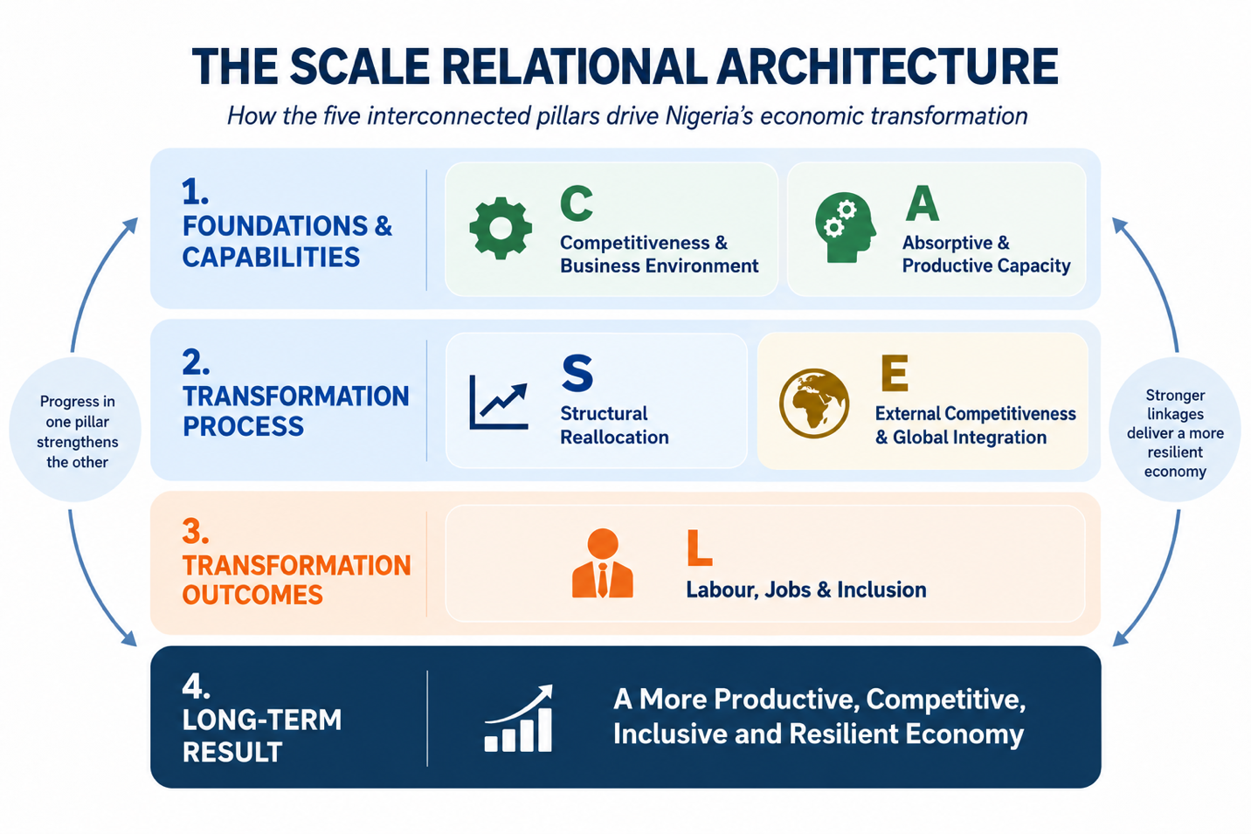
The importance of SCALE, therefore, is in the relationships between and among the pillars. Comparing performance across the three layers enables policymakers to identify where Nigeria’s transformation pathway is strengthening and where it is breaking down. For example, relatively strong foundational conditions and productive capabilities accompanied by weak transformation processes may suggest that improvements in the business environment and productive capabilities have yet to translate into structural upgrading. Strong transformation processes alongside weak transformation outcomes may indicate that productivity gains are not translating into broad-based employment or inclusion. This architecture provides the conceptual basis for NETI. The next section explains how the five dimensions are translated into indicators, benchmarks, scores and an overall index.

How the Nigeria Economic Transformation Index (NETI) Measures Economic Transformation
The Nigeria Economic Transformation Index (NETI) translates the SCALE framework into a composite measure of Nigeria’s transformation performance. The index does this by combining indicators across the five pillars into comparable scores that can be tracked over time.

The index is designed around the principle that transformation should be assessed against the characteristics of a more productive, competitive and inclusive economy, rather than against Nigeria’s past performance alone. This matters because a country can improve relative to its historical position and still be far from the level of capability or structural change associated with successful transformation.

Indicator selection
Indicators are selected to reflect the specific economic processes captured by each SCALE pillar. Emphasis was placed on measures that have a clear conceptual relationship with transformation, can be tracked consistently over time and provide useful information on Nigeria’s productive structure, capabilities, competitiveness and labour market outcomes. The indicators are organised within each pillar around related dimensions. For example, Structural Reallocation captures changes in the sectoral composition of output and employment while External Competitiveness & Global Integration focuses on export structure, export sophistication, resilience and integration into international markets. The same logic is applied across the remaining pillars.

Table 1: Nigeria Economic Transformation Index: Pillars, Dimensions, Focus and Indicators
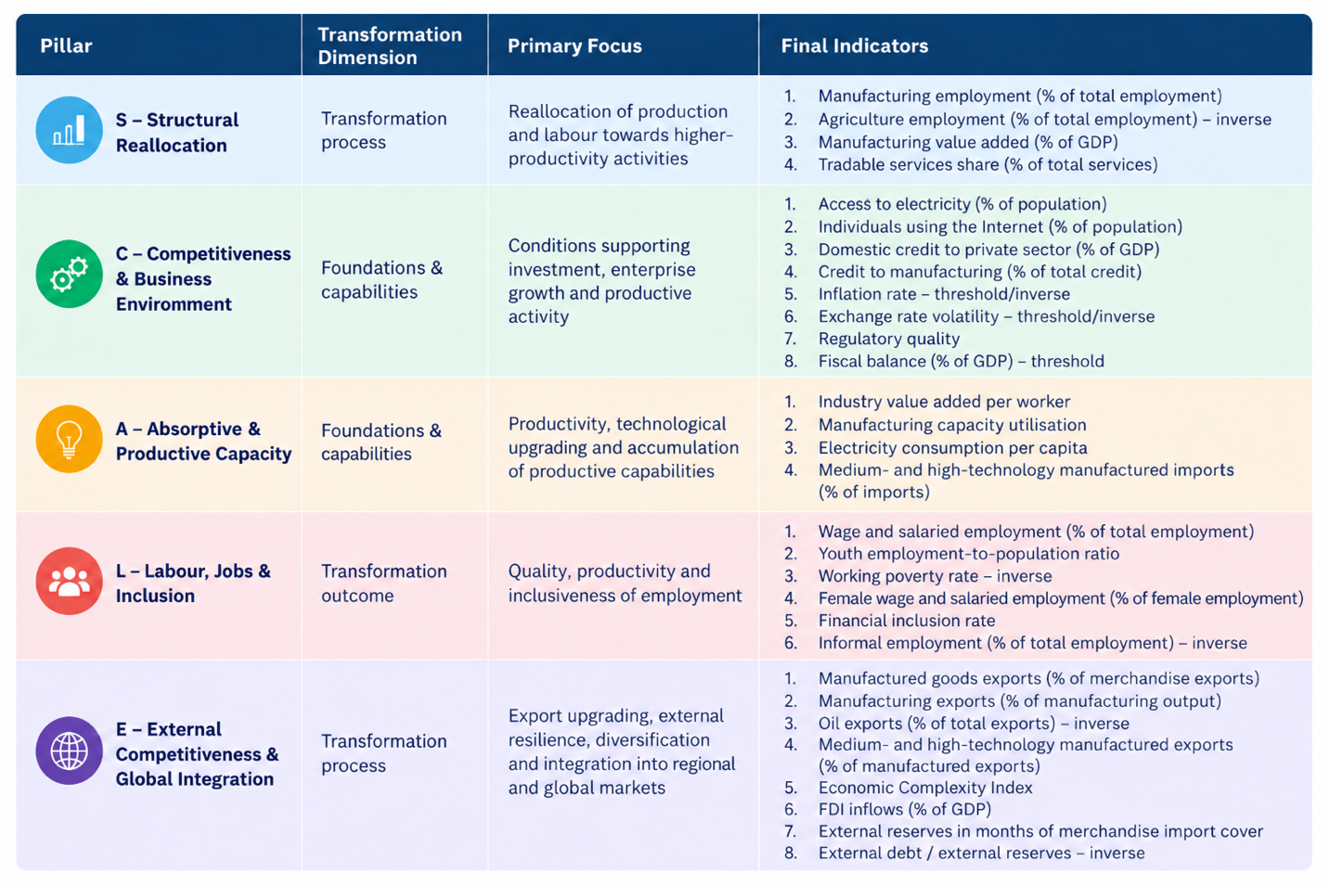
5  Pillars | 3  Layers | 30  Indicators

Benchmarking and normalisation
The indicators used in NETI are expressed in different units and scales. Each indicator is therefore normalised to a score between 0 and 100, where higher scores represent stronger transformation performance.

The benchmarks used for normalisation are fixed reference points derived from a combination of comparator-country experience, empirical distributions and context-specific judgement. The purpose is to establish credible lower and upper bounds that reflect meaningful levels of transformation performance.

For indicators where higher values indicate stronger performance, scores increase as the observed value moves towards the upper benchmark. For indicators where lower values are preferable, such as working poverty, informal employment or oil export dependence, the scoring direction is reversed. Threshold-based scoring is used where a simple linear relationship would be misleading, particularly for variables such as inflation, exchange rate volatility and fiscal balance (as a percentage of GDP).

Fixed benchmarks also improve comparability over time. Nigeria’s score changes because its performance changes, rather than because the reference points shift each year. Further details on benchmark selection, normalisation and indicator-specific scoring are provided in the Methodology Note.

Figure 5: NETI Benchmark Component
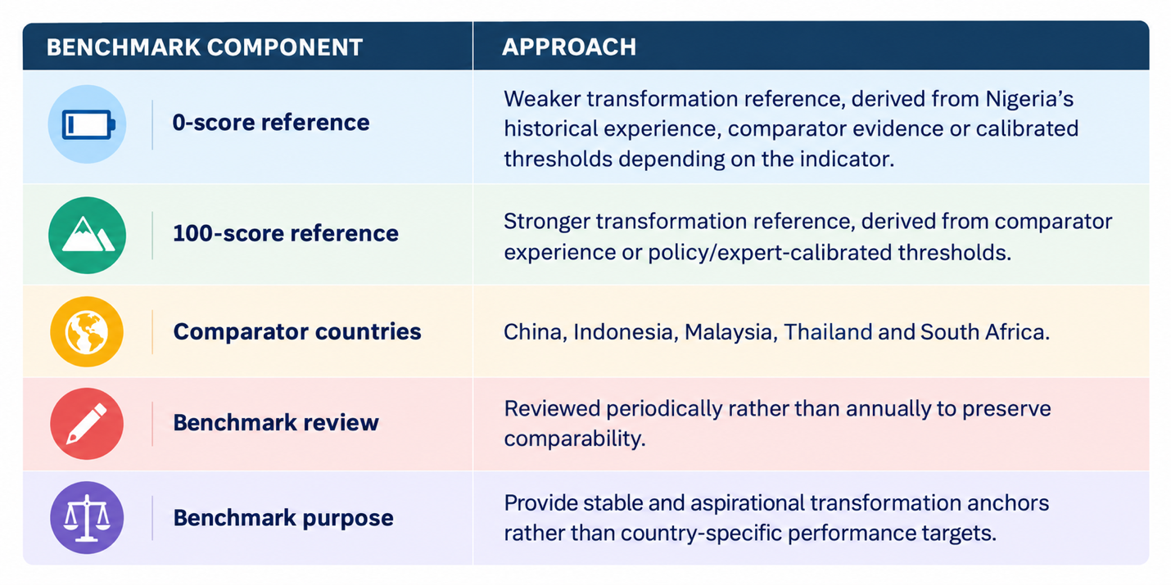
Aggregation and weighting
Indicator scores are aggregated first within their respective pillars and then across the five SCALE pillars to produce the overall NETI score. Within each pillar, indicators are assigned weights according to their conceptual importance to the transformation process. The weighting structure limits excessive influence from closely related indicators. Detailed indicator weights are presented in the methodology table.

The weighting structure reflects the relational logic of the framework. Competitiveness & Business Environment (C) and Absorptive & Productive Capacity (A) together receive 45 percent of the overall weight because they capture the foundational conditions and productive capabilities that support investment, productivity growth and structural transformation. Structural Reallocation (S) and External Competitiveness & Global Integration (E) receive a combined 35 percent, reflecting their role as the principal transformation processes. Labour, Jobs & Inclusion (L) accounts for the remaining 20 percent as the main labour market and inclusion outcome.

The resulting index is expressed as:

NETI = 0.175S + 0.225C + 0.225A + 0.20L + 0.175E

The difference in weights recognises the importance of foundational conditions and productive capabilities in sustaining transformation, while retaining substantial weight on structural change, external competitiveness and labour market outcomes. Robustness tests using alternative weighting structures produced a similar overall trajectory.

Figure 6: NETI Weighting and Rationale
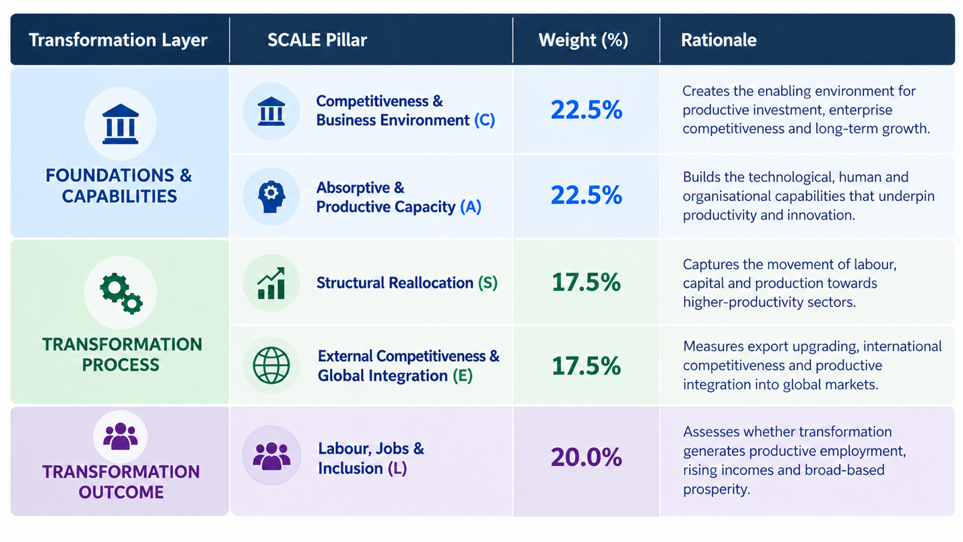

How to Read and Interpret NETI
NETI is designed as a diagnostic instrument to reveal how Nigeria’s economic transformation has changed over the long term, identify areas of strength and weakness and assess the distance between current performance and the conditions associated with transformation. NETI is constructed using fixed benchmarks informed by the experience of countries, alongside indicator-specific policy and methodological considerations. Scores should, therefore, be interpreted against the fixed benchmarks, which are long-term transformation reference points rather than immediate annual policy targets. The benchmark shows what has been achieved elsewhere and the scale of improvement that may be required for Nigeria to build a more productive, competitive and inclusive economy.

Figure 7: Four Ways to Read NETI
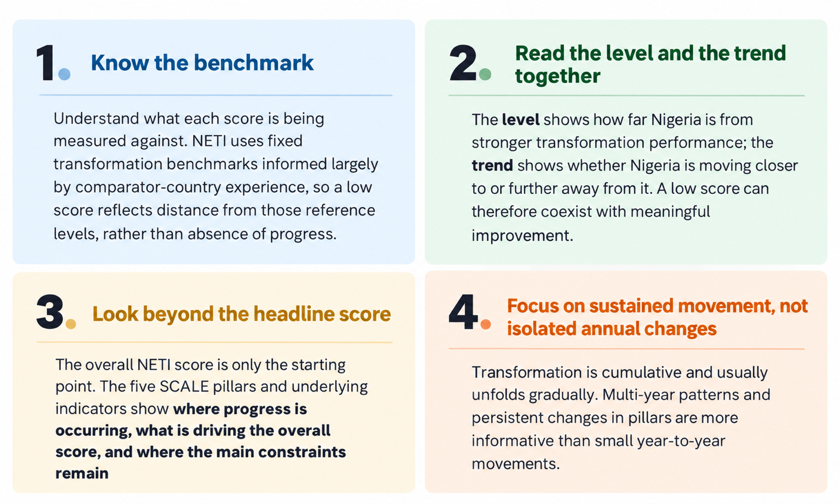

Higher scores indicate greater progress towards a productive, competitive, diversified, inclusive and resilient economy. Lower scores indicate a greater distance from the benchmark levels and point to areas where structural constraints remain. Because transformation is gradual and can take several years to manifest, small annual movements or changes in scores should be interpreted carefully. Sustained movements over several years are more informative than short-term fluctuations.

To facilitate interpretation, NETI classifies both the headline and pillar scores into five diagnostic bands.

Table 2: Interpreting NETI Scores
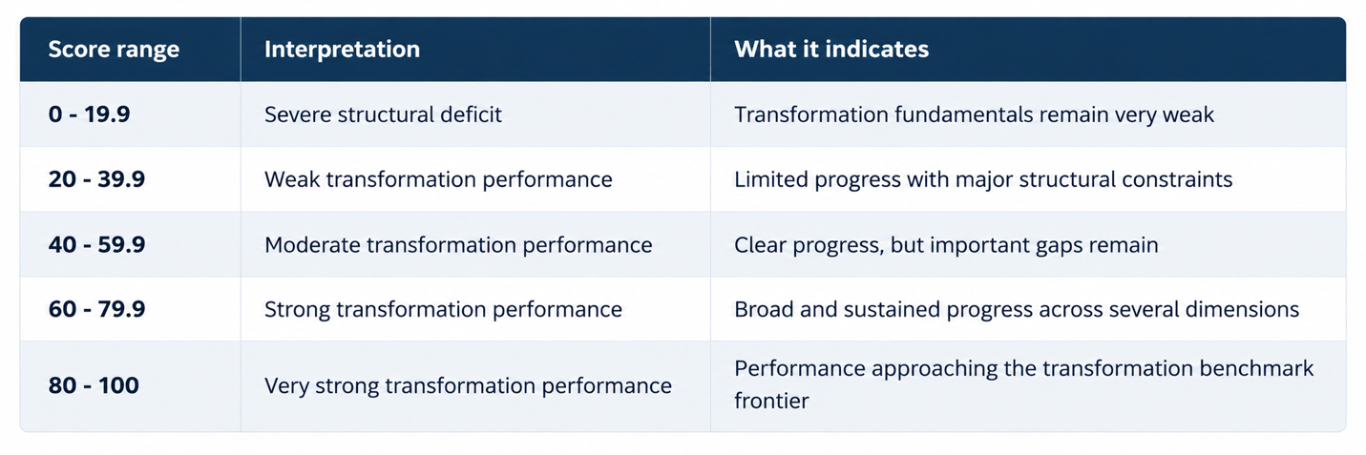

CHAPTER 3: WHAT NETI REVEALS ABOUT NIGERIA

Nigeria’s Transformation Trajectory, 2000 – 2025
Over the past twenty-five years, Nigeria’s transformation trajectory has been marked by periods of improvement followed by reversal. The weighted Nigeria Economic Transformation Index (NETI) stood at 27.0 in 2000 and rose steadily through the 2000s, reaching a peak of 34.0 in 2008. These gains were, however, not sustained. Performance weakened over the following decade, recovered briefly in 2019, and then deteriorated again before a modest improvement in 2025. By 2025, the index stood at 25.4, slightly below its 2000 level and still within the Weak Transformation Performance range. The twenty-five-year record therefore points to progress without sufficient accumulation. Nigeria demonstrated that stronger transformation performance was possible, but was unable to sustain and build on those gains over time.

Figure 8: Nigeria Economic Transformation Index, 2000 - 2025

What might Nigeria’s NETI score have been in 2025 if earlier progress had been sustained? The scale of transformation foregone in Nigeria is substantial. Between 2000 and 2008, NETI rose from 27.0 to 34.0, equivalent to an average improvement of about 0.9 points per year. Had that pace been sustained, Nigeria’s NETI score would have approached 49.0 by 2025, compared with an actual score of 25.4. Although transformation is not linear, this illustrative counterfactual highlights the scale of gains foregone when periods of progress are not sustained.

2000 - 2011: Nigeria’s strongest period of transformation progress
The strongest period in the NETI series came during the 2000s. From 27.0 in 2000, the index rose to 34.0 in 2008, before easing to 32.5 in 2011. The improvement coincided with a period of relatively strong economic growth, expanding telecommunications, banking sector reforms, higher investment and generally more favourable external conditions. But the scale of the transformation gain was modest relative to the economic expansion. At its 2008 peak, NETI was 7.0 points above its 2000 level. The improvement reflected gains in productive capacity, labour outcomes and external competitiveness & integration, while Structural Reallocation and Competitiveness & Business Environment remained below their 2000 levels. Rapid economic growth therefore coincided with some transformation gains, although these gains were neither broad-based across all pillars nor sustained over time.

2012 - 2017: Momentum fades and earlier gains begin to unwind
From 2012, NETI moved onto a weaker path as it fell from 30.9 in 2012 to 28.7 in 2017. The decline became more pronounced after the oil price shock and the 2016 recession, a period marked by foreign exchange shortages, weaker investment and tighter economic conditions.

By 2017, much of the improvement recorded during the previous decade had been lost. The Nigerian economy was still changing in terms of its structure; however, the transformation process was becoming increasingly uneven. Some dimensions continued to improve while others were weakening, a pattern that becomes clearer when the five NETI pillars are examined separately.

2018 - 2025: A brief rebound followed by a sharper deterioration
A temporary improvement emerged towards the end of the 2010s, with NETI rising to 30.2 in 2019. From 2020, however, the index moved onto a weaker path, declining from 29.8 in 2020 to 24.6 in 2024. This period coincided with a difficult domestic and external environment. The COVID-19 shock was followed by the global food and energy price pressures associated with the war in Ukraine, while Nigeria also faced high inflation, foreign exchange shortages and a significant exchange rate premium.

The deterioration continued through 2021 - 2024 as weaknesses in productive capacity and the business environment weighed on the index. NETI then recorded a modest improvement to 25.4 in 2025, supported by stronger performance in some pillars, although the overall score remained slightly below its 2000 level of 27.0 and well below the 34.0 peak reached in 2008.

A record of progress without accumulation
The main finding from the twenty-five-year series is the absence of sustained, cumulative progress. Nigeria recorded periods in which transformation indicators improved and declined - NETI rose from 27.0 in 2000 to a peak of 34.0 in 2008 and fell to 25.4 in 2025. The trajectory therefore shows that Nigeria was able to make progress and struggled to sustain and build on those gains over time.

This distinction between movement and cumulative transformation is important. Successful transformation builds on previous gains and is sustained over long periods. Productive capabilities deepen, firms become more competitive, economic activity shifts towards higher-productivity uses, exports become more sophisticated and employment outcomes improve. Nigeria’s NETI trajectory instead shows periods of advancement followed by reversal.

Understanding why the overall index changed requires looking beyond the aggregate score. The next section examines how the five SCALE pillars shaped Nigeria’s transformation performance.

Box 1: How should recent macroeconomic reforms be read in NETI?
Nigeria has implemented a major set of economic reforms since 2023, including changes to the foreign exchange market, removal of fuel subsidies and tighter macroeconomic management. The IMF’s 2026 Article IV assessment notes that these reforms have strengthened macroeconomic stability, rebuilt external buffers and improved the functioning of the foreign exchange market (IMF, 2026). The CBN has also continued reforms aimed at greater FX market transparency, price discovery and market unification.

NETI recognises macroeconomic stability as an important foundation for transformation, with its wider effects becoming visible over time through investment, production, exports, employment and household welfare. The index therefore tracks whether improvements in the macroeconomic environment are accompanied by stronger outcomes across these parts of the economy.

There is also an important sequencing issue. Reforms can impose short-term adjustment costs before longer-term benefits emerge. Exchange rate adjustment, higher energy prices and tighter financial conditions can weaken household purchasing power and raise operating costs for firms, even where the objective is to improve macroeconomic stability and resource allocation over time.

The 2025 NETI score shows a modest improvement after four consecutive annual declines from 2020 to 2024. Whether this marks the beginning of a sustained recovery is still too early to determine. The more important question is whether recent improvements in some macroeconomic indicators are accompanied over time by stronger competitiveness, productive investment, firm capabilities, exports and quality employment. NETI is designed to track that process as it unfolds.

What Has Driven the Overall Score?
Nigeria’s overall NETI trajectory was shaped by divergent movements across the five SCALE pillars. Between 2000 and 2025, some dimensions of transformation improved while others weakened.

Table 3: Nigeria Economic Transformation Index and Pillars
SCALE pillar | 2000 | 2025 | Change
Structural Reallocation | 11.2 | 35.5 | +24.3
Competitiveness & Business Environment | 45.1 | 23.8 | -21.3
Absorptive & Productive Capacity | 26.9 | 12.5 | -14.4
Labour, Jobs & Inclusion | 29.5 | 31.7 | +2.2
External Competitiveness & Global Integration | 16.9 | 26.5 | +9.6
NETI | 27.0 | 25.4 | -1.6

Figure 9: Trajectory of NETI Pillars, 2000 - 2025

Structural reallocation became the main source of progress
The strongest positive movement came from the Structural Reallocation pillar, which increased from 11.2 in 2000 to 35.5 in 2025. This pillar contributed 4.3 points to the headline index over the period. The improvement reflects important shifts in the structure of the economy: agriculture’s share of employment declined, manufacturing employment increased and tradable services expanded. Overall, these changes show that the allocation of labour and economic activity in 2025 was considerably different from that recorded in 2000.

By 2025, Structural Reallocation had become the strongest of the five SCALE pillars. Labour moved away from agriculture, where a large share of employment remains subsistence-based and low-productivity, and some of that labour moved towards sectors with greater productivity potential, including manufacturing and tradable services. The development gains from this shift depend on the productivity of the activities absorbing labour and on whether productivity within those activities continues to rise.

Figure 10: Structural Reallocation in Nigeria, 2000 - 2025

Competitiveness moved in the opposite direction
Competitiveness & Business Environment pillar recorded the largest decline, falling from 45.1 in 2000 to 23.8 in 2025, reducing the overall NETI by about 4.8 points. This deterioration occurred despite clear improvements in indicators such as electricity access and internet connectivity. These gains were outweighed by persistent weaknesses in productive finance, periods of high inflation and exchange rate volatility, weaker fiscal performance and relatively poor regulatory quality. The contrast with Structural Reallocation shows that while the economy was changing its sectoral composition, business conditions captured by NETI ended the period substantially weaker than where they began.

Figure 11: Competitiveness & Business Environment in Nigeria, 2000 - 2025

Productive capacity weakened alongside competitiveness
Absorptive & Productive Capacity deteriorated substantially, falling from 26.9 to 12.5 and reducing the overall NETI score by about 3.2 points. This pillar improved through much of the first decade, reaching its strongest levels in the late 2000s, before declining for a long period. By 2025, weak industrial value added per worker, low electricity consumption per person and limited technological absorption weighed down the pillar. The decline suggests that productive capabilities did not keep pace with the shifts in labour and economic activities across sectors.

Figure 12: Absorptive & Productive Capacity in Nigeria, 2000 - 2025

Labour outcomes improved modestly
Labour, Jobs & Inclusion increased modestly from 29.5 in 2000 to 31.7 in 2025, contributing about 0.4 points to the headline index. The pillar remained within the Weak Transformation Performance range throughout the period. Financial inclusion expanded and working poverty declined, while wage and salaried employment remained limited, informality stayed high, the youth employment-to-population ratio remained below the benchmark and female wage employment remained low. This pillar showed that Nigeria made limited progress in improving the quality, formality and inclusiveness of employment at scale.

Figure 13: Labour, Jobs & Inclusion in Nigeria, 2000 - 2025

External competitiveness improved, although export upgrading remains weak
External Competitiveness & Global Integration increased from 16.9 in 2000 to 26.5 in 2025, adding about 1.7 points to the headline index. The improvement reflects stronger performance in some aspects of external resilience and integration, including reserve adequacy and the relationship between external debt and reserves, alongside changes in export composition. The pillar nevertheless remained within the Weak Transformation Performance range in 2025. Manufactured exports still account for a small share of total exports, manufacturing remains weakly export-oriented, economic complexity is low and FDI remains below the benchmark associated with stronger global integration. Nigeria strengthened its external position in important aspects and this was not matched by comparable progress in export sophistication and domestic productive capability.

Figure 14: External Competitiveness & Global Integration in Nigeria, 2000 - 2025

Uneven performance across pillars
By the end of the period, the structure of NETI looked very different from where it began. In 2000, Competitiveness & Business Environment was the strongest pillar and Structural Reallocation the weakest. By 2025, Structural Reallocation had become the strongest pillar, while Competitiveness and Productive Capacity had fallen sharply.

Overall, three pillars - Structural Reallocation, Labour, Jobs & Inclusion and External Competitiveness & Global Integration - improved between 2000 and 2025, while Competitiveness & Business Environment and Absorptive & Productive Capacity ended the period lower than where they started. Nigeria made progress in shifting labour and economic activity across sectors and in strengthening some aspects of external integration, while the capabilities and competitive conditions needed to turn those shifts into sustained productivity gains weakened.

Nigeria’s Transformation Gap
The NETI transformation gap shows how far Nigeria is from the level associated with Strong Transformation Performance. The transformation gap measures the distance between Nigeria’s current NETI score and the threshold for Strong Transformation Performance. Under the NETI interpretation framework, scores between 60 and 79.9 represent strong transformation performance. The lower boundary of this range – 60 – is therefore used as the reference point. This does not imply that a score of 60 means that economic transformation is complete. It provides a practical benchmark at which stronger performance becomes evident across the different dimensions captured by the index.

In 2025, Nigeria recorded a weighted NETI score of 25.4, leaving a transformation gap of 34.6 points relative to the threshold of 60. The historical pattern shows that Nigeria moved closer to stronger transformation performance during the 2000s when NETI peaked at 34.0 – a gap of 26. By 2025, the gap had widened to 34.6 points, reflecting the inability of the country to sustain progress over a long period.

Figure 15: Nigeria’s Transformation Gap, 2000 – 2025

The transformation gap shifts attention from the headline score to the breadth of improvement still required across the economy. Narrowing it will require sustained progress across several dimensions rather than improvement in a single pillar. Stronger macroeconomic and business conditions must support greater productive investment; investment must strengthen firm capabilities and productivity; structural reallocation must move workers into increasingly productive activities; and deeper domestic capabilities must support more sophisticated exports and better-quality employment. Progress in one pillar will have greater effect when it generates gains elsewhere.

Diagnosing Nigeria's Transformation Challenge
The previous sections show that Nigeria’s overall transformation performance weakened from 2000 to 2025 even as several dimensions improved. Structural Reallocation, Labour, Jobs & Inclusion and External Competitiveness & Global Integration strengthened, while Competitiveness & Business Environment and Absorptive & Productive Capacity deteriorated substantially. NETI therefore remained within the Weak Transformation Performance category throughout the period. The more important question is why periods of progress have repeatedly failed to build into sustained transformation.

This section provides a diagnosis of how the different parts of the transformation process interact, why gains in one area have often not been matched by gains elsewhere, and why periods of improvement have repeatedly lost momentum.

Structural reallocation has run ahead of productive deepening
Structural Reallocation recorded the strongest improvement in NETI, while Absorptive & Productive Capacity deteriorated substantially. The trend of both pillars points to a mismatch between changes in the allocation of labour and economic activity and the development of productive capabilities within the economy. Reallocation is more likely to support lasting transformation when the sectors absorbing labour also raise productivity, deepen technological capabilities and expand productive employment. But results at the indicator level showed that while manufacturing employment and tradable services expanded, industrial productivity, capacity utilisation, electricity consumption and technological absorption remained weak. This implies that beyond where labour moves to, an important issue is whether the activities receiving labour become more productive and capable over time.

Foundational conditions and productive capabilities weakened
The deterioration in Competitiveness & Business Environment and Absorptive & Productive Capacity helps explain why gains elsewhere have been difficult to sustain. Nigerian firms operate with high production costs, macroeconomic instability, inadequate and expensive power, limited access to productive finance and regulatory constraints. These conditions affect day-to-day business activities and also shape whether firms can make the longer-term investments needed to acquire machinery, adopt technology, develop skills and expand production.

When firms face difficult operating conditions and are unable to invest consistently, capability accumulation slows. This weakens productivity growth, limits the ability of firms to scale and reduces their capacity to compete in domestic and international markets. Weak foundational and capability pillars therefore affect the wider transformation process rather than remaining confined to the business environment.

External integration has provided limited support for upgrading
Nigeria made some progress in external competitiveness and integration. The expansion of domestic refining is already beginning to alter Nigeria’s petroleum trade profile. Even so, the broader upgrading of the export structure remains limited. Manufactured exports are still small, manufacturing remains weakly export-oriented and economic complexity is low. The challenge is not only whether Nigeria participates in international markets, but also whether that participation generates sufficient learning, technology transfer and domestic capability building.

External integration can reinforce domestic capability accumulation when firms are able to learn, upgrade and enter higher-value markets. In Nigeria, that channel remains underdeveloped. The stronger external position captured in NETI has not yet been matched by comparable progress in export sophistication and firm-level productive capabilities.

Labour market gains have remained limited
A transformed economy should generate a larger share of formal, stable and more productive jobs as firms expand and higher-productivity activities deepen. As NETI shows, Nigeria remains a long distance from that outcome. Although the Labour, Jobs & Inclusion pillar improved modestly over the period, several challenges remain - the quality of employment remains a major constraint; informal employment accounted for 93 percent of total employment in Q2 2024, while wage and salaried employment was about 14.4 percent. Structural changes have not yet generated employment outcomes at the scale and quality required to support broad improvements in incomes and living standards.

The core challenge is weak alignment across the transformation system
Overall, the NETI results show that progress across the different dimensions of transformation has been uneven and weakly connected in Nigeria. For instance, improvements in structural reallocation, external integration and financial inclusion were not matched by comparable gains in productive capacity, firm competitiveness and employment quality. Nigeria’s experience also suggests that periods of improvement have often lost momentum before gains could accumulate over time. The central diagnosis from NETI is therefore that Nigeria has changed where economic activity takes place faster than it has strengthened the conditions and productive capabilities that determine what that activity can produce, how competitively it can produce it and the quality of jobs it can create.

CHAPTER 4: FROM STRUCTURAL CHANGE TO PRODUCTIVE TRANSFORMATION

What the NETI Diagnosis Means for Policy
Based on findings in the previous chapter, one major challenge facing Nigeria is converting changes in the structure of the economy into sustained improvements in productivity, productive capacity and employment quality. To address this challenge, Nigeria needs a transformation agenda that strengthens the foundations for productive investment while improving the capacity of firms and sectors to scale, upgrade and compete. The objective should be to align the different dimensions of transformation around a clear set of outcomes such as raising productivity and domestic value creation, strengthening competitiveness, diversifying production and exports, and expanding productive employment.

The foundational conditions are central to this agenda because they shape the conditions under which firms invest, learn and expand. Macroeconomic stability, reliable infrastructure, access to productive finance and regulatory predictability influence whether firms can commit to the long-term investments needed to acquire machinery, adopt technology, develop skills and increase production. Their importance therefore lies in creating conditions for sustained investment, higher capacity utilisation, stronger productivity and more competitive firms.

Policy must also pay attention to the quality of structural change. As labour moves across sectors, the activities absorbing workers need to become more productive. This requires stronger firms in manufacturing, agro-processing and tradable services, supported by access to finance, reliable power and infrastructure, technology, skills and stronger links to domestic and external markets.

A further implication of NETI is the need for better coordination across policy areas and levels of government. Industrial, trade, infrastructure, finance, technology and skills policies cannot operate effectively in isolation. Clearer objectives, stronger coordination across ministries and agencies, and more effective federal/state government delivery mechanisms are needed to ensure that reforms and investments work towards the same transformation goals. Also, transformation requires policies and institutions that can sustain progress over time rather than repeatedly resetting priorities and delivery arrangements.

Policy success should therefore be judged not only by whether reforms are announced or projects completed, but also by whether they improve productive outcomes. Progress should ultimately be visible in stronger investment, higher productivity, deeper domestic value creation, more sophisticated exports and better jobs. NETI provides a framework for tracking that progress and identifying where further policy attention is needed.

These implications provide the basis for the policy priorities discussed in subsequent sections.

Rebuild the Foundations of Productive Transformation
Rebuilding Nigeria’s foundational conditions is essential to sustained productive transformation. Firms need an environment in which they can plan over longer horizons, invest in machinery and technology, develop capabilities, expand production and raise productivity. The priorities below focus on strengthening the macroeconomic, financial and productive conditions required for this process.

Make macroeconomic stability support productive investment
- The Central Bank of Nigeria, working with relevant economic ministries, should sustain efforts to reduce inflation and exchange rate instability so firms can plan investment over a longer horizon. Particular attention is needed on food inflation, where improvements in agricultural productivity, logistics, storage and market access can help address persistent supply pressures.
- Macroeconomic performance should be assessed alongside indicators of productive investment and firm activity. The Ministry of Finance and the Ministry of Industry, Trade and Investment should regularly track private investment, manufacturing capacity utilisation, credit to productive sectors, business expansion and investment in manufacturing, agro-processing and tradable services. This would provide a clearer picture of whether improving macroeconomic conditions are being accompanied by stronger productive activity.
- Macroeconomic stability should also translate into more predictable access to finance and foreign exchange for productive firms. Particular attention should be given to firms importing machinery, equipment and critical industrial inputs, for which financing constraints or uncertain access to foreign exchange can delay investment and raise production costs. Policymakers should therefore monitor the availability, tenor and cost of investment finance, as well as access to foreign exchange for productive imports.

Direct more finance towards productive activity
- Government should work with development finance institutions, commercial banks and the capital market to expand the availability of long-term finance for manufacturing, agro-processing and other tradable activities. The focus should be on longer-tenor funding for machinery, plant expansion, technology adoption and working capital for firms with credible production and export potential. Financing programmes should be assessed by the additional investment, output and productivity they generate, rather than by the volume of funds disbursed alone.

Lower the cost of production and help firms upgrade
- Federal and state governments should concentrate infrastructure and enterprise support around productive clusters and value chains with established activity or clear investment potential. Reliable power, transport and logistics should be combined with technology support, standards and skills development. The objective should be to lower operating costs while enabling firms to improve production processes, adopt technology and scale.

NETI points to two financing challenges: the overall depth of private sector credit and the share reaching productive activities. Nigeria remains well below the transformation benchmarks on both measures. For manufacturing credit, the framework uses an expert-calibrated upper reference point of 40 percent of total credit. This should be interpreted as a benchmark for assessing the depth of productive finance rather than as a prescribed credit-allocation target.

Turn Structural Reallocation into Productive Deepening
The improvement in Structural Reallocation shows that the composition of employment and economic activity in Nigeria is already changing. Policy should now focus on the quality of that change, particularly in agriculture, manufacturing and tradable services.

Raise agricultural productivity and strengthen links to agro-industry
- The Federal Ministry of Agriculture and Food Security, working with state governments and the private sector, should focus on raising productivity in agriculture while strengthening links between farmers, processors and markets. Better access to inputs, irrigation, storage, logistics, extension services and finance can raise output per worker and support a gradual movement of labour out of low-productivity farming.

Deepen manufacturing around viable value chains and industrial clusters
- The Ministry of Industry, Trade and Investment and state governments should concentrate industrial policy on value chains where Nigeria already has strong domestic demand, access to inputs or emerging firm capabilities. Support should combine infrastructure, finance, skills, standards and logistics around viable clusters rather than relying on broad incentives spread thinly across many sectors. The objective should be to raise capacity utilisation, deepen domestic value addition and help firms move into larger and more productive operations.

Scale tradable services with stronger productivity and firm growth
- Nigeria should build deliberately on the expansion of tradable services such as ICT, finance and professional services, while paying closer attention to productivity, scale and linkages with the rest of the economy. Policy should support firms that can sell beyond local markets and provide productivity-enhancing services to manufacturing, agriculture and other productive sectors.

NETI benchmarks provide a sense of the direction and scale of structural change associated with stronger transformation performance. The upper reference points are around 23 percent of employment in manufacturing and 31 percent of GDP from manufacturing.

Make External Integration an Engine of Capability Building
Nigeria has made some progress in its external position, particularly in building external resilience and improving market integration. The policy challenge is to deepen the quality of external integration by using trade and investment to expand domestic capabilities. This means helping Nigerian firms meet higher export standards, adopt technology, enter larger markets and build stronger links with domestic suppliers.

Use exports to drive firm upgrading
- The Ministry of Industry, Trade & Investment, working with the Nigerian Export Promotion Council and relevant sector agencies, should focus export support on firms and sectors with clear potential to scale into regional and global markets. Support should combine export finance, standards certification, logistics, market intelligence and trade facilitation. The aim is to help firms move from occasional exporting to sustained participation in larger markets, where competition and customer requirements can drive improvements in quality and productivity.

Link FDI more closely to domestic production
- Investment policy should place greater emphasis on the domestic linkages created by foreign investment. Incentives for large investors should be tied more closely to supplier development, local sourcing where commercially viable, workforce training and technology transfer. The objective should be to ensure that FDI contributes not only capital, but also to the growth of domestic firms and the accumulation of productive capabilities.

Use regional integration to build scale
- Nigeria should use AfCFTA and regional markets as a platform for firms to build scale before competing more widely. Trade policy should identify products and services where Nigerian firms can expand regional market share, while reducing logistics, standards and border constraints that limit cross-border trade. For many firms, regional markets can provide an important route towards larger-scale production, stronger export capability and deeper participation in global value chains.

NETI benchmarks provide reference points for the scale of external upgrading associated with stronger transformation performance. Selected benchmarks include 40 percent for manufactured goods in total exports, 40 percent for manufacturing exports relative to manufacturing output, 50 percent for medium- and high-technology products within manufactured exports, and 4.5 percent of GDP for FDI. These are transformation reference points derived from comparator evidence and indicator-specific calibration rather than fixed targets for Nigeria.

Improve the Employment Outcomes of Structural Change
Despite modest improvement in the Labour, Jobs & Inclusion score, informality remains high, wage employment is limited and young people and women continue to face weak labour market outcomes. The policy challenge is to ensure that changes in the productive structure of the economy are accompanied by more formal, stable and better-paid work. This requires expanding firms and sectors capable of creating productive employment at scale, improving the match between skills and labour demand and creating more viable pathways from informal to formal work.

Expand the sectors that can absorb labour productively
- Employment policy should be linked more closely to the growth of firms and sectors capable of creating productive jobs at scale. Manufacturing, agro-processing, logistics, construction and tradable services can absorb significant numbers of workers as firms expand. Federal and state governments should therefore assess major industrial, infrastructure and investment programmes partly by the number and quality of jobs they generate.

Align skills policy with actual demand from firms
- Skills programmes should respond more directly to the capabilities employers need. Government, training institutions and the private sector should build stronger links between technical and vocational training, apprenticeships and sectors where firms are making investments and hiring. Practical skills that improve workers’ chances of moving into productive employment should be prioritised.

Create clearer pathways from informal to formal work
- Policy should make it easier for viable informal firms to grow, improve working conditions and move gradually towards formalisation. This requires better access to finance and business development support, alongside incentives that reward firm expansion and better employment practices. Formalisation should be linked to firm growth and productivity rather than treated mainly as a compliance exercise.

Sequence, Coordinate and Sustain the Transformation Agenda
Macroeconomic instability, high production costs and financing constraints require immediate attention, while firm capabilities, export sophistication and labour market upgrading take longer to build. The policy challenge is therefore to sequence reforms, so that near-term stabilisation creates room for sustained capability accumulation and productive upgrading.

Near term: restore the conditions for productive investment
- The immediate priority should be to strengthen macroeconomic stability and reduce the major costs facing firms. This means sustaining progress on inflation and exchange rate stability, preserving external buffers, improving access to productive finance, and addressing power, logistics and regulatory constraints that directly affect investment decisions. NETI provides useful reference points for this phase, such as single-digit inflation and annual exchange rate volatility below 2 percent.

Medium term: deepen firm and sector capabilities
- As macroeconomic conditions improve, greater emphasis should be placed on firm upgrading and productive deepening. Priorities should include technology adoption, stronger industrial and agro-processing value chains, supplier development, improved standards and targeted support for firms with the potential to scale. Manufacturing and tradable services are particularly important because of their potential to raise productivity, generate exports and expand productive employment.

Longer term: build complexity, exports and better jobs
- The longer-term objective should be to move Nigeria towards a more sophisticated productive structure, with more firms competing in regional and global markets, stronger economic complexity, deeper domestic value creation and a labour market with more wage employment and lower informality. Progress at this stage will depend heavily on the capabilities accumulated in the earlier phases.

Put coordination and accountability at the centre
- The federal government should establish a clear transformation framework that brings together the economic ministries, the CBN, relevant agencies and state governments around a small set of shared outcomes. These should include firm investment, productivity, capacity utilisation, export participation, wage employment and technology adoption. Regular reporting against these indicators would make it easier to see where reforms are working and where progress is being held back.

Continuity of government policies and programmes is important in achieving transformational outcomes. Nigeria’s experience shows that periods of progress have often been interrupted before gains could accumulate. A credible transformation agenda therefore requires institutions and policy arrangements capable of sustaining investment, capability building and productivity growth over time.

NETI can support this process by providing a national transformation scorecard. Its indicators and benchmarks can be used to track whether improvements in macroeconomic stability, productive finance, capacity utilisation, manufacturing, exports and employment are moving Nigeria closer to stronger transformation performance.

CONCLUSION
Over the past twenty-five years, Nigeria’s economy has changed in several ways. Output has expanded, labour has moved away from agriculture mostly into services, access to finance and digital infrastructure has widened and the export structure has begun to change. These changes, however, have occurred alongside persistent weaknesses in productive capacity, firm competitiveness and employment quality. Informality remains widespread, manufacturing exports are still small, and the productive capabilities required for firms to scale, upgrade and compete remain uneven.

One important lesson from the Nigeria Economic Transformation Index (NETI) is that economic transformation requires cumulative capability building. Firms need time to invest, learn, adopt technology and build organisational capabilities. Sectors need time to develop supplier networks, skills, standards and infrastructure. Export capability and productive employment also emerge gradually as these capabilities deepen. Where macroeconomic instability, weak infrastructure, limited productive finance or policy discontinuity interrupt this process, individual reforms may produce gains without creating a sustained transformation path.

The time required to build these capabilities also matters. Many of the NETI benchmarks reflect levels achieved by economies such as China, Indonesia, Malaysia, South Africa and Thailand after long periods of industrial development, capability building and export expansion. Their experience supports the point that productive investment, firm capability, institutional coordination and policy implementation accumulate over time. Short reform episodes are unlikely to be enough where priorities change repeatedly or earlier gains are allowed to dissipate.

NETI should therefore be used to track whether Nigeria is becoming more productive in practice: whether firms are investing, scaling and upgrading; whether production and exports are becoming more sophisticated; whether workers are moving into better jobs; and whether these gains are being sustained. The goal should be to make structural change more productive and durable.

The real task is to move from structural change to productive transformation. Nigeria’s economic structure has already changed considerably since 2000. The next phase will depend on whether those changes are accompanied by stronger firms, deeper sector capabilities, higher productivity, more sophisticated exports and better employment. Progress on these fronts would narrow Nigeria’s transformation gap and move the economy closer to the levels of performance captured by the stronger NETI benchmarks.

REFERENCES
Central Bank of Nigeria (CBN). Statistical Bulletin, various years. Abuja: Central Bank of Nigeria.
Central Bank of Nigeria (CBN). (2026). Monetary Policy Committee decisions and monetary policy publications. Abuja: Central Bank of Nigeria.
Chenery, H., & Syrquin, M. (1975). Patterns of Development, 1950-1970. Oxford University Press.
Erumebor, W. (2025). Structural Transformation, Productivity Growth and Employment in Nigeria. PhD Thesis, SOAS, University of London. DOI: https://doi.org/10.25501/SOAS.00547729
Harvard Growth Lab. Atlas of Economic Complexity, various years.
International Labour Organization (ILO). ILOSTAT database, various years.
International Monetary Fund (IMF). (2026). Nigeria: 2026 Article IV Consultation-Press Release; Staff Report; and Statement by the Executive Director for Nigeria. IMF Country Report No. 26/125. https://doi.org/10.5089/9798229048286.002
Kuznets, S. (1966). Modern Economic Growth: Rate, Structure, and Spread. Yale University Press.
Lewis, W. A. (1954). Economic development with unlimited supplies of labour. The Manchester School, 22(2), 139–191.
McMillan, M., Page, J., Booth, D., & te Velde, D. W. (2017). Supporting Economic Transformation: An Approach Paper. Overseas Development Institute.
Nardo, M., Saisana, M., Saltelli, A., Tarantola, S., Hoffman, A., & Giovannini, E. (2008). Handbook on Constructing Composite Indicators: Methodology and User Guide. OECD Publishing.
National Bureau of Statistics (NBS). (2024a). Nigeria Labour Force Survey, Q2 2024. Abuja: NBS.
National Bureau of Statistics (NBS) (2024b). Nigeria Labour Force Survey. Annual Report 2023. Abuja: NBS
National Bureau of Statistics (NBS). (2026). Foreign Trade in Goods Statistics, Q4 2025. Abuja: NBS.
National Bureau of Statistics (NBS). (2026a). Nigerian Gross Domestic Product Report, Q4 2025. Abuja: NBS.
National Bureau of Statistics (NBS). (2026b). Capital Importation report, Q1 2026. Abuja: NBS.
National Bureau of Statistics (NBS). Capital Importation reports, various years. Abuja: NBS.
United Nations Industrial Development Organization (UNIDO). UNIDO Statistics Data Portal, various years.
World Bank. World Development Indicators, various years.
World Bank. Worldwide Governance Indicators, various years.
World Bank. Global Findex Database, various years.
World Bank. (2026). Nigeria Development Update, April 2026. Washington, DC: World Bank.

APPENDIX 1

Part I: Nigeria Economic Transformation Index (NETI) Methodology Note

Technical specification
This note documents the construction of the Nigeria Economic Transformation Index (NETI) used in this report. It sets out the indicator architecture, data treatment, benchmark selection, normalisation rules, weighting, aggregation and interpretation framework for the 2000-2025 series. The objective is to make the index transparent and reproducible while preserving a stable basis for comparison over time.

1. Conceptual architecture
NETI operationalises the SCALE framework through five pillars organised into three analytical layers. Competitiveness & Business Environment (C) and Absorptive & Productive Capacity (A) constitute the Foundations & Capabilities layer; Structural Reallocation (S) and External Competitiveness & Global Integration (E) capture Transformation Processes; and Labour, Jobs & Inclusion (L) captures Transformation Outcomes. The published index contains 30 indicators.

2. Data preparation and smoothing
Raw annual observations are first assembled from the relevant national and international sources. NETI then applies a three-year trailing moving average to each indicator before normalisation. For year t, the smoothed value is the arithmetic mean of available observations for t, t-1 and t-2. The smoothing rule reduces the influence of one-off annual movements and is consistent with NETI’s purpose as a structural rather than cyclical measure.

Missing observations are retained as missing values rather than automatically coded as zero. Where an indicator is unavailable for a year, the weights of the available indicators within that pillar are proportionally rescaled. This rule is particularly relevant for indicators with incomplete historical coverage. The index does not use a moving historical minimum or maximum for normalisation.

3. Normalisation
Each smoothed indicator is converted to a score between 0 and 100 using fixed benchmark bounds. For positive indicators, higher values receive higher scores. For inverse indicators, lower values receive higher scores. Scores outside the benchmark range are capped at 0 or 100.

Positive indicator: Score = MAX(0, MIN(100, 100 * (X - L) / (U - L))).
Inverse indicator: Score = MAX(0, MIN(100, 100 * (U - X) / (U - L))).

For threshold indicators, NETI uses policy- or risk-relevant bands rather than assuming that the relationship between the indicator and transformation performance is linear across all values. Inflation, exchange rate volatility, fiscal balance, reserve import cover and the external-debt-to-reserves ratio use threshold-based scoring.

4. Benchmark selection
Benchmarks are fixed transformation reference points rather than annual policy targets. They are derived from a combination of comparator-country experience, Nigeria-specific historical information, policy thresholds and expert calibration. The principal comparator economies are China, Indonesia, Malaysia, Thailand and South Africa. For several indicators, the stronger benchmark is based on the median of comparator peaks or troughs; in other cases the benchmark is moderated to reflect Nigeria’s context, data quality or the economic meaning of the indicator.

Fixed benchmarks allow a score in an earlier year to retain the same meaning when new observations are added. The benchmark architecture should not be revised annually. A full review approximately every five years is preferable, unless a major data or conceptual change requires an earlier revision.

5. Indicator specification, benchmarks and weights
Pillar | Indicator | Direction | 0-score reference | 100-score reference | Weight | Primary source | Benchmark basis
S | Manufacturing employment (% total employment) | Positive | 7.03 | 23.30 | 30% | UNIDO | Comparator-informed
S | Agriculture employment (% total employment) | Inverse | 52.71 (worst) | 21.70 (best) | 20% | WDI / ILO modelled estimates | Comparator-informed
S | Manufacturing value added (% GDP) | Positive | 6.20 | 30.90 | 30% | NBS back-casted GDP series | Comparator-informed
S | Tradable services share (% total services) | Positive | 18.43 | 40.00 | 20% | NBS back-casted GDP series | Expert-calibrated
C | Access to electricity (% population) | Positive | 43.12 | 100.00 | 20% | WDI | Comparator-informed
C | Individuals using the Internet (% population) | Positive | 0.04 | 90.87 | 7.5% | WDI | Comparator-informed
C | Domestic credit to private sector (% GDP) | Positive | 5.36 | 100.00 | 15% | CBN / NBS | Comparator-informed; upper bound moderated
C | Credit to manufacturing (% total credit) | Positive | 11.44 | 40.00 | 15% | CBN | Expert-calibrated
C | Inflation rate | Threshold | ≥20 = 0 | ≤9 = 100 | 12.5% | NBS | Policy-calibrated
C | Exchange rate volatility | Threshold | ≥10 = 0 | ≤2 = 100 | 12.5% | CBN monthly official exchange rate series | Policy / expert-calibrated
C | Regulatory quality | Positive | 21.66 | 60.50 | 10% | World Bank WGI | Comparator-informed
C | Fiscal balance (% GDP) | Threshold | ≤−8 = 0 | ≥−3 = 100 | 7.5% | CBN Statistical Bulletin; IMF for recent years | Policy / expert-calibrated
A | Industry value added per worker (constant 2015 US$) | Positive | 4,316.77 | 23,558.10 | 30% | WDI | Comparator-informed
A | Manufacturing capacity utilisation (%) | Positive | 32.27 | 80.00 | 25% | CBN | Expert-calibrated
A | Electricity consumption (kWh per capita) | Positive | 99.20 | 1,500.00 | 20% | WDI | Comparator-informed; upper bound moderated
A | Medium- and high-technology manufactured imports (% total imports) | Positive | 38.37 | 60.00 | 25% | UNIDO | Expert-calibrated
L | Wage and salaried employment (% total employment) | Positive | 5.85 | 62.30 | 20% | WDI / ILO modelled estimates | Comparator-informed
L | Youth employment-to-population ratio, ages 15–24 (%) | Positive | 56.21 | 65.00 | 15% | WDI / ILO modelled estimates | Expert-calibrated
L | Working poverty rate (%) | Inverse | 55.30 (worst) | 5.00 (best) | 20% | ILO | Comparator-informed / adjusted
L | Female wage and salaried employment (% female employment) | Positive | 3.57 | 64.60 | 15% | WDI / ILO modelled estimates | Comparator-informed
L | Financial inclusion rate (%) | Positive | 10.00 | 89.00 | 10% | World Bank Global Findex / national series | Comparator-informed
L | Informal employment rate (%) | Inverse | 92.77 (worst) | 54.40 (best) | 20% | ILO / NBS | Comparator-informed with Nigeria upper anchor
E | Manufactured goods exports (% total exports) | Positive | 6.00 | 40.00 | 12.5% | UNIDO | Expert-calibrated
E | Manufacturing exports (% manufacturing output) | Positive | 6.74 | 40.00 | 12.5% | UNIDO / NBS | Expert-calibrated
E | Oil exports (% total exports) | Inverse | 95.11 (worst) | 45.00 (best) | 10% | NBS / CBN | Expert-calibrated
E | Medium- and high-technology manufactured exports (% manufactured exports) | Positive | 6.41 | 50.00 | 17.5% | UNIDO | Expert-calibrated
E | Economic Complexity Index | Positive | −2.30 | 0.93 | 12.5% | Harvard Growth Lab Atlas of Economic Complexity | Comparator-informed
E | FDI inflows (% GDP) | Positive | 0.00 | 4.50 | 20% | WDI | Comparator-informed
E | External reserves in months of merchandise import cover | Threshold | ≥12 = 100 | ≤4 = 0 | 7.5% | CBN / NBS, derived | Expert-calibrated
E | External debt / external reserves | Threshold / inverse | ≥4.0 = 0 | ≤0.5 = 100 | 7.5% | CBN, derived | Expert-calibrated

6. Threshold scoring
Threshold indicators are scored linearly between their best and worst thresholds and capped outside the range. Inflation receives a score of 100 at 9 percent or below and 0 at 20 percent or above. Exchange rate volatility receives 100 at 2 percent or below and 0 at 10 percent or above. Fiscal balance receives 100 at -3 percent of GDP or better and 0 at -8 percent or worse. Reserve import cover receives 0 at four months or less and 100 at 12 months or more. The external-debt-to-reserves ratio receives 100 at 0.5 or below and 0 at 4.0 or above.

Exchange rate volatility is calculated from the official monthly end-period naira/US dollar series as the standard deviation of monthly log changes within each year, expressed in percentage terms. The annual volatility measure is then subjected to the same three-year trailing moving average used elsewhere in NETI.

7. Pillar aggregation and overall NETI weighting
Normalised indicator scores are aggregated within each pillar using fixed indicator weights. Where an indicator is missing, the available weights are proportionally rescaled. The five pillar scores are then combined using the following weights: Structural Reallocation 17.5 percent; Competitiveness & Business Environment 22.5 percent; Absorptive & Productive Capacity 22.5 percent; Labour, Jobs & Inclusion 20 percent; and External Competitiveness & Global Integration 17.5 percent.

NETI = 0.175S + 0.225C + 0.225A + 0.20L + 0.175E

The weighting gives greater combined emphasis to the foundational and capability pillars while retaining substantial weight on the transformation processes and labour market outcomes. An equal-pillar-weight robustness check produces a broadly similar long-run trajectory; in the current series, the equally weighted index is approximately unchanged between 2000 and 2025, while the baseline weighted index records a modest decline.

8. Interpretation bands and transformation gap
Score | Interpretation | Meaning
0 - 19.9 | Severe structural deficit | Transformation fundamentals remain very weak
20 - 39.9 | Weak transformation performance | Limited progress with major structural constraints
40 - 59.9 | Moderate transformation performance | Clear progress, but important gaps remain
60 - 79.9 | Strong transformation performance | Broad and sustained progress across several dimensions
80 - 100 | Very strong transformation performance | Performance approaching the transformation benchmark frontier

The transformation gap is defined as the distance between the observed NETI score and 60, the lower boundary of the Strong Transformation Performance band. It is a distance-to-benchmark measure, not a percentage measure of how transformed the economy is.

9. Interpretation and limitations
NETI should be read using both levels and trends. The level indicates Nigeria’s distance from the fixed transformation reference points; the trend shows whether that distance is narrowing or widening. A pillar can therefore improve substantially while remaining in a weak performance band. The headline index should always be interpreted alongside the five pillar scores and, where necessary, the underlying indicators.

NETI is a diagnostic composite index that identifies patterns, relative strengths, weaknesses and co-movements across the transformation system; it does not by itself establish causal relationships between indicators or pillars. Several indicators are proxies for broader concepts such as productive capability, institutional quality and technological absorption, and some historical series rely on internationally harmonised or modelled estimates. Results should therefore be interpreted as a structured diagnostic rather than a causal estimate of the effect of any individual policy.

10. Review cycle and reproducibility
The indicator set, benchmarks and weights constitute the Version 1 NETI architecture. Annual data updates should preserve the fixed methodology so that historical scores remain comparable. A substantive methodological review should normally take place approximately every five years, covering indicator relevance, data quality, comparator economies, benchmark ranges and weighting. Any future methodological change should be documented and, where it materially affects the historical series, accompanied by a back-cast for comparability.

PART II: NETI Methodology Note - Benchmark Construction and Comparator Evidence
This section documents the evidence used to set NETI benchmark ranges. It complements the main technical specification table by showing how comparator-country experience, Nigeria’s historical performance and policy or expert-calibrated thresholds informed the 0-100 scoring references.

Benchmark approach. NETI uses fixed benchmark ranges rather than annual or sample-dependent minima and maxima. Three sources are used:
- Comparator-country evidence where sufficiently comparable data exist;
- Nigeria’s historical experience, particularly to anchor weak performance ranges; and
- Policy or expert calibration where international data are incomplete or a threshold treatment is more appropriate. For inverse indicators, the stronger outcome is the lower numerical value. Threshold indicators are scored against defined performance bands rather than treated as simple linear positive or inverse variables.

Comparator economies. The comparator set comprises China, Indonesia, Malaysia, Thailand and South Africa. These economies are used as reference cases because they provide relevant evidence on industrialisation, structural change, export upgrading and productive capability accumulation. Comparator values are not adopted mechanically: where the median of comparator peaks or troughs is implausible for Nigeria’s current context, the benchmark is moderated and the adjustment is stated explicitly.

Interpretation. The 0-score and 100-score references are transformation reference points. They are intended to preserve comparability over time while indicating the scale of movement associated with stronger transformation performance.

S - Structural Reallocation
This pillar captures changes in the allocation of labour and production across sectors. Empirical benchmarks are drawn mainly from observed comparator peaks or troughs, while tradable services is expert-calibrated because a consistent long-run cross-country series is not available.

Benchmark ranges and basis
Indicator | Direction | 0-score reference | 100-score reference | Benchmark basis | Rationale
Manufacturing employment (% of total employment) | Positive | 7.03 | 23.3 | Comparator-informed | 100-score reference: median of comparator peaks.
Agriculture employment (% of total employment) | Inverse | 52.71 | 21.7 | Comparator-informed | 100-score reference: median of comparator troughs.
Manufacturing value added (% of GDP) | Positive | 6.20 | 30.9 | Comparator-informed | 100-score reference: median of comparator peaks.
Tradable services share (% of total services) | Positive | 18.43 | 40.0 | Expert-calibrated | Used because comparable historical data are incomplete.
Note: References are fixed for Version 1 of NETI and are subject to periodic methodological review rather than annual revision.

Comparator-country evidence
Country | Manufacturing employment (%) | Agriculture employment (%) | Manufacturing share of GDP (%)
China | 29.2 | 21.7 | 32.0
Indonesia | 14.4 | 27.3 | 32.0
Malaysia | 23.3 | 9.2 | 30.9
Thailand | 24.7 | 4.5 | 19.1
South Africa | 16.3 | 28.6 | 30.9
Median | 23.3 | 21.7 | 30.9
Sources: UNIDO and World Development Indicators (WDI). Tradable services benchmark is expert-calibrated.
Note: Figures represent peak performance across the reference period - the highest observed values for positive indicators and the lowest observed values for inverse indicators such as agriculture employment.

C – Competitiveness & Business Environment
This pillar captures the operating conditions that influence firms’ ability to invest, produce and expand. Empirical reference points are combined with policy-relevant thresholds for macroeconomic and fiscal stability.

Benchmark ranges and basis
Indicator | Direction | 0-score reference | 100-score reference | Benchmark basis | Rationale
Access to electricity (% of population) | Positive | 43.12 | 100.0 | Comparator-informed | 100-score reference: median of comparator peaks.
Individuals using the internet (% of population) | Positive | 0.04 | 90.87 | Comparator-informed | 100-score reference: median of comparator peaks.
Domestic credit to private sector (% of GDP) | Positive | 5.36 | 100.0 | Comparator-informed, moderated | Comparator median is higher; upper reference moderated to 100% of GDP.
Credit to manufacturing (% of total credit) | Positive | 11.44 | 40.0 | Expert-calibrated | Cross-country sectoral credit data are not sufficiently comparable.
Inflation rate | Threshold | ≥20% | ≤9% | Policy-calibrated | Linear scoring between the two thresholds.
Exchange rate volatility | Threshold | ≥10% | ≤2% | Policy-calibrated | Annual volatility of monthly log returns; linear scoring between thresholds.
Regulatory quality | Positive | 21.66 | 60.5 | Comparator-informed | 100-score reference: median of comparator peaks.
Fiscal balance (% of GDP) | Threshold | ≤−8% | ≥-3% | Policy/expert-calibrated | -3% reflects a prudent fiscal reference;  -8% represents severe fiscal stress.
Note: References are fixed for Version 1 of NETI and are subject to periodic methodological review rather than annual revision.

Comparator-country evidence
Country | Electricity access (%) | Internet users (%) | Private credit (% GDP) | Regulatory quality
China | 100 | 92.0 | 194.2 | 68.8
Indonesia | 100 | 72.8 | 39.4 | 57.4
Malaysia | 100 | 98.0 | 158.5 | 70.0
South Africa | 90 | 78.4 | 142.4 | 60.5
Thailand | 100 | 90.9 | 164.1 | 56.8
Median | 100 | 90.9 | 158.5 | 60.5
Sources: WDI and World Bank Worldwide Governance Indicators. Manufacturing credit, inflation, exchange rate volatility and fiscal-balance references are calibrated separately.

A – Absorptive & Productive Capacity
This pillar captures the depth of productive capability, including productivity, utilisation of installed capacity, productive electricity use and technological absorption.

Benchmark ranges and basis
Indicator | Direction | 0-score reference | 100-score reference | Benchmark basis | Rationale
Industry value added per worker (constant 2015 US$) | Positive | 4,316.77 | 23,558.1 | Comparator-informed | 100-score reference: median of comparator peaks.
Manufacturing capacity utilisation (%) | Positive | 32.27 | 80.0 | Expert-calibrated | Represents strong, sustained use of installed manufacturing capacity.
Electric power consumption (kWh per capita) | Positive | 99.20 | 1,500 | Comparator-informed, adjusted | Set near the lower-energy-intensity comparator range rather than the comparator median.
Medium- and high-technology manufactured imports (% of imports) | Positive | 38.37 | 60.0 | Expert-calibrated | Proxy for technological absorption; capped to avoid overstatement.
Note: References are fixed for Version 1 of NETI and are subject to periodic methodological review rather than annual revision.

Comparator-country evidence
Country | Industry value added per worker (constant 2015 US$) | Electric power consumption (kWh per capita)
China | 30,069.8 | 6,523.7
Indonesia | 14,903.6 | 1,445.2
Malaysia | 32,866.5 | 5,241.0
South Africa | 23,558.1 | 4,716.4
Thailand | 17,261.0 | 2,965.2
Median | 23,558.1 | 4,716.4
Source: WDI. The electricity-consumption 100-score reference is deliberately moderated to 1,500 kWh per capita.

L – Labour, Jobs & Inclusion
This pillar captures whether structural and productive change is associated with stronger labour market outcomes and wider economic inclusion. Comparator evidence is used where available, while youth employment is calibrated to avoid rewarding high employment rates among 15-24-year-olds.

Benchmark ranges and basis
Indicator | Direction | 0-score reference | 100-score reference | Benchmark basis | Rationale
Wage and salaried employment (% of total employment) | Positive | 5.85 | 62.3 | Comparator-informed | 100-score reference: median of comparator peaks.
Youth employment-to-population ratio, ages 15–24 (%) | Positive | 56.21 | 65.0 | Expert-calibrated | Upper reference moderated to 65% to reflect education participation and avoid over-rewarding very high youth EPR.
Working poverty rate (%) | Inverse | 55.3 | 5.0 | Comparator-informed, adjusted | The comparator median is close to zero; the 100-score reference is moderated to 5% to avoid requiring near-elimination of working poverty for a maximum score.
Female wage and salaried employment (% of female employment) | Positive | 3.57 | 64.6 | Comparator-informed | 100-score reference: median of comparator peaks.
Financial inclusion rate (%) | Positive | 10.0 | 89.0 | Comparator-informed | 100-score reference: median comparator level.
Informal employment rate (%) | Inverse | 92.77 | 54.4 | Comparator-informed / Nigeria anchor | 100-score reference: median comparator level; weak reference reflects Nigeria’s recent level.
Note: References are fixed for Version 1 of NETI and are subject to periodic methodological review rather than annual revision.

Comparator-country evidence
Country | Wage employment (%) | Working poverty (%) | Female wage employment (%) | Financial inclusion (%) | Informal employment (%)
China | 62.3 | 0.1 | 64.6 | 89.0 | 54.4
Indonesia | 48.5 | 5.6 | 40.8 | 56.0 | 80.2
Malaysia | 74.6 | 0.1 | 82.1 | 89.0 | 21.8
South Africa | 85.9 | 14.5 | 88.2 | 85.0 | 31.3
Thailand | 49.7 | 0.1 | 50.2 | 96.0 | 62.6
Median | 62.3 | 0.1 | 64.6 | 89.0 | 54.4
Sources: WDI, ILO/ILOSTAT and World Bank Global Findex. Youth EPR and the working poverty 100-score reference are calibrated separately.

E - External Competitiveness & Global Integration
This pillar captures export upgrading, diversification, integration into regional and global markets and external resilience. Comparator evidence is strongest for economic complexity and FDI; the export-structure and resilience indicators use explicit expert- or policy-calibrated reference ranges.

Benchmark ranges and basis
Indicator | Direction | 0-score reference | 100-score reference | Benchmark basis | Rationale
Manufactured goods exports (% of merchandise exports) | Positive | 6.00 | 40.0 | Expert-calibrated | Represents a materially more diversified merchandise export structure.
Manufacturing exports (% of manufacturing output) | Positive | 6.74 | 40.0 | Expert-calibrated | Captures export orientation of domestic manufacturing.
Oil exports (% of total exports) | Inverse | 95.11 | 45.0 | Expert-calibrated | Lower oil dependence represents stronger diversification.
Medium- and high-technology manufactured exports (% of manufactured exports) | Positive | 6.41 | 50.0 | Expert-calibrated | Proxy for export sophistication.
Economic Complexity Index | Positive | −2.30 | 0.93 | Comparator-informed | 100-score reference: median of comparator peaks.
FDI inflows (% of GDP) | Positive | 0.00 | 4.5 | Comparator-informed | 100-score reference: median of comparator peaks.
External reserves in months of merchandise import cover | Threshold | ≤4 months | ≥12 months | Expert/policy-calibrated | Annual import-cover ratio is calculated first and then smoothed.
External debt / external reserves | Inverse threshold | ≥4.0 | ≤0.5 | Expert-calibrated | Measures external obligations relative to available reserve buffers.
Note: References are fixed for Version 1 of NETI and are subject to periodic methodological review rather than annual revision.

Comparator-country evidence
Country | Economic Complexity Index | FDI inflows (% of GDP)
China | 1.38 | 4.5
Indonesia | 0.34 | 2.9
Malaysia | 1.07 | 5.4
South Africa | 0.59 | 9.7
Thailand | 0.93 | 4.3
Median | 0.93 | 4.5
Sources: Harvard Growth Lab/Atlas of Economic Complexity and WDI. Export-structure, import-cover and debt-to-reserves benchmarks are calibrated separately.

How comparator evidence is used
- Comparator data provide evidence for the scale of transformation observed elsewhere; they do not determine every NETI benchmark mechanically. Where data are robust and conceptually comparable, the median of comparator peaks or troughs is used as the stronger reference point.
- Where a comparator median would create an implausibly demanding or structurally inappropriate reference for Nigeria, the benchmark is moderated. Domestic credit and electricity consumption are examples of this treatment.
- Where international series are unavailable, inconsistent or poorly matched to the NETI concept, expert calibration is used explicitly. This applies to indicators such as tradable services, manufacturing credit, capacity utilisation and several export-structure measures.
- Threshold indicators are used when economic performance is better represented by a desirable range than by unrestricted linear scaling. Inflation, exchange rate volatility, fiscal balance, import cover and the external-debt-to-reserves ratio are treated in this way.
- The benchmark architecture will be reviewed periodically, approximately every five years, so that NETI remains demanding and relevant without breaking time-series comparability through frequent changes in reference points.

APPENDIX 2: NETI HISTORICAL SCORES
Table A1: NETI and pillar scores, 2000-2025
Year | NETI | Structural Reallocation | Competitiveness & Business Environment | Absorptive & Productive Capacity | Labour, Jobs & Inclusion | External Competitiveness & Global Integration
2000 | 27.0 | 11.2 | 45.1 | 26.9 | 29.5 | 16.9
2001 | 26.8 | 11.9 | 41.7 | 28.0 | 29.6 | 17.6
2002 | 27.4 | 13.1 | 36.0 | 31.4 | 30.3 | 22.3
2003 | 28.5 | 13.6 | 34.7 | 35.2 | 31.1 | 24.0
2004 | 30.4 | 13.0 | 36.9 | 36.4 | 32.3 | 29.7
2005 | 30.9 | 11.4 | 34.3 | 36.4 | 33.1 | 36.3
2006 | 31.8 | 10.2 | 35.1 | 36.5 | 33.9 | 40.9
2007 | 33.3 | 9.3 | 38.2 | 38.0 | 34.4 | 43.6
2008 | 34.0 | 8.7 | 39.7 | 38.0 | 35.1 | 45.8
2009 | 33.7 | 8.4 | 37.2 | 38.0 | 35.7 | 46.7
2010 | 32.9 | 8.5 | 34.7 | 35.8 | 36.1 | 47.5
2011 | 32.5 | 8.7 | 36.7 | 33.2 | 37.0 | 44.8
2012 | 30.9 | 9.9 | 38.4 | 31.4 | 37.0 | 34.6
2013 | 30.8 | 12.1 | 41.3 | 29.5 | 37.1 | 30.6
2014 | 30.7 | 15.3 | 41.5 | 29.7 | 36.8 | 26.4
2015 | 31.0 | 17.8 | 42.7 | 28.5 | 36.3 | 26.3
2016 | 29.1 | 19.5 | 35.9 | 27.7 | 35.3 | 24.7
2017 | 28.7 | 20.6 | 34.0 | 27.1 | 33.5 | 26.4
2018 | 28.8 | 22.1 | 36.4 | 25.0 | 31.3 | 27.9
2019 | 30.2 | 23.9 | 39.3 | 24.8 | 29.4 | 32.4
2020 | 29.8 | 26.2 | 40.0 | 22.0 | 26.6 | 33.7
2021 | 28.4 | 28.5 | 38.4 | 17.7 | 25.2 | 32.7
2022 | 26.3 | 31.4 | 35.2 | 10.9 | 25.4 | 30.8
2023 | 24.8 | 33.8 | 27.3 | 9.8 | 28.2 | 27.8
2024 | 24.6 | 35.1 | 24.6 | 10.2 | 30.4 | 25.9
2025 | 25.4 | 35.5 | 23.8 | 12.5 | 31.7 | 26.5

Note: Scores range from 0 to 100, where higher scores indicate stronger transformation performance. Pillar scores and the overall NETI score are based on normalised indicator values and the weighting structure described in the methodology note.

Table A2: Indicator Scores, Selected Years (0 - 100 scale)
Pillar | Indicator | 2000 | 2008 | 2015 | 2020 | 2025
S | Manufacturing employment (% of total employment) | 17.6 | 9.0 | 8.8 | 23.8 | 43.4
S | Agricultural employment (% of total employment) (inverse) | 0.0 | 16.3 | 38.6 | 44.0 | 60.0
S | Manufacturing share of GDP (constant 2019 prices) | 19.7 | 2.8 | 12.4 | 10.2 | 8.2
S | Tradable services share of total services (constant 2019 prices) | 0.0 | 9.4 | 18.5 | 35.8 | 40.0
C | Access to electricity (% population) | 0.0 | 10.9 | 19.3 | 22.2 | 31.0
C | Individuals using the Internet (% population) | 0.0 | 7.4 | 22.9 | 32.8 | 44.5
C | Domestic credit to private sector (% GDP) | 0.0 | 4.8 | 8.8 | 8.3 | 15.2
C | Credit to manufacturing (% total credit) | 75.6 | 7.6 | 3.2 | 13.2 | 11.5
C | Inflation rate (inverse) | 100.0 | 100.0 | 100.0 | 70.5 | 0.0
C | Exchange rate volatility (inverse) | 100.0 | 100.0 | 98.0 | 100.0 | 0.0
C | Regulatory quality | 13.0 | 25.5 | 30.7 | 27.1 | 27.5
C | Fiscal balance (% GDP) | 100.0 | 100.0 | 100.0 | 78.4 | 100.0
A | Industry value added per worker (constant 2015 US$) | 41.6 | 34.6 | 23.5 | 14.8 | 0.0
A | Manufacturing capacity utilisation (%) | 0.0 | 47.2 | 50.8 | 35.6 | 40.8
A | Electricity consumption (kWh per capita) | 0.1 | 2.0 | 6.0 | 2.9 | 3.1
A | Medium- and high-technology manufactured imports (% total imports) | 57.6 | 61.8 | 30.2 | 32.3 | 6.8
L | Wage and salaried employment (% total employment) | 0.0 | 6.2 | 11.3 | 12.7 | 13.7
L | Youth employment-to-population ratio, ages 15–24 (%) | 100.0 | 100.0 | 71.8 | 6.3 | 59.9
L | Working poverty rate (%) (inverse) | 0.0 | 30.9 | 51.3 | 52.8 | 53.7
L | Female wage and salaried employment (% female employment) | 0.0 | 4.4 | 8.4 | 10.0 | 10.9
L | Financial inclusion rate (%) | 0.0 | 12.0 | 35.9 | 53.6 | 75.9
L | Informal employment rate (%) (inverse) | 72.4 | 54.3 | 40.8 | 28.7 | 0.0
E | Manufactured goods exports (% total exports) | 2.4 | 6.6 | 10.3 | 8.7 | 9.2
E | Manufacturing exports (% manufacturing output) | 8.6 | 51.4 | 25.2 | 9.1 | 0.4
E | Oil exports (% total exports) (inverse) | 11.3 | 0.3 | 10.3 | 28.7 | 27.8
E | Medium- and high-technology manufactured exports (% manufactured exports) | 5.1 | 45.7 | 27.4 | 78.4 | 52.4
E | Economic Complexity Index | - | - | 15.4 | 6.3 | 0.7
E | FDI inflows (% GDP) | 25.8 | 49.0 | 18.6 | 6.9 | 8.0
E | External reserves in months of merchandise import cover | 60.1 | 100.0 | 37.9 | 75.0 | 80.4
E | External debt / external reserves (inverse) | 23.3 | 100.0 | 100.0 | 94.6 | 75.8
 | NETI | 27.0 | 34.0 | 31.0 | 29.8 | 25.4
S = Structural Reallocation; C = Competitiveness & Business Environment; A = Absorptive & Productive Capacity; L = Labour, Jobs & Inclusion; E = External Competitiveness & Global Integration.

Note: Values shown are normalised indicator scores on a 0-100 scale, not raw indicator values. Higher scores indicate stronger performance. For inverse indicators, higher scores reflect lower values of the underlying variable. Smoothed series are used where specified in the methodology. Blank cells indicate data were unavailable or the series was not used for those years.

